
DEPARTMENT OF GEOGRAPHY AND RESOURCE MAMAGEMENT

MIZORAM UNIVERSITY, AIZAWL – 796004

CERTIFICATE

This is to certify that Vanneihtluanga has prepared a project under my Supervision on the topic of “Market Survey in Tomato” in the Department of Geography and Resource Management, Mizoram University, Aizawl.

This field project has been the outcome of his original work and it does not form a part of any other dissertations submitted for the award of any other degrees.

Dated: Aizawl
The 20th November 2023

(Prof. Ch. Uday Bhaskara Rao)
Supervisor
Department of Geography & RM
Mizoram University, Aizawl

ACKNOWLEDGEMENT


Project inspiration and motivation have always played a key role in the success of any venture.
We express our sincere thanks to Mr. Prof. Ch. Uday Bhaskara Rao because the completion of this study could not have been possible without the expertise of him, our beloved supervisors.
Moreover, he encourages us to the highest peak and to provide us the opportunity to prepare the project. Most importantly his valuable guidance and kind. Supervisor given to us throughout the course which shaped the present work as it shows.

(VANNEIHTLUANGA)
ROLL NO-24
III SEMESTER
DEPARTMENT OF GEOGRAPHY & RM

CONTENT Page no
Certificate
Acknowledgement
Content
List of tables
List of maps
Chapter: 1 Introduction
1.1 Introduction
1.2Study area
1.3Objectives of Study
1.4 Data and Methodology
1.5 Chaptalization

Chapter:2 Sources of data

Chapter: 3 Literature Review

Chapter: 4 Tomato Market in AMC Area
4.1 Introduction
4.2 Source of Tomato
4.3 Rate or Cost
4.4 Consumption
4.5Waste/ Post Harvest Management

Chapter: 5 Roles and Responsibilities
5.1 Roles and Responsibilities of Mizo
5.2 Roles and Responsibilities of Government
Chapter: 6 Survey Findings

Chapter: 7 Conclusions

Chapter -- 1
INTRODUCTION:

Tomato originated in Western South America, and their cultivation dates back to ancient Aztec and Inca civilization since 500 BC. Spanish explorer brought tomato to Europe in the 16th century, but they were initially met with suspicious and considered ornamental rather than edible. The first recorded cookbook mentioning tomatoes is from 1692 in Italy.
Tomato were introduced to India during the colonial period by Portuguese. The Portuguese brought tomatoes to Goa in the 16th century. Overtime, tomatoes gained acceptance and became an integral part of India cooking.
The origin of Tomatoes in Mizoram are not well documented but introduced through trade and exploration, their cultivation became integrated into the local agricultural landscape over time. Tomatoes gained popularly in the 18th & 19th centuries, eventually becoming a staple in many dishes, particularly after varieties with desirable culinary traits were developed.
1.1 Introduction:
Market survey is the survey research and analysis of the market for a particular product/service which includes the investigation into customer inclinations. Marketing is a human activity directed at satisfying needs and wants through exchange processes. It includes all actions designed to generate and facilitate any replace intended to satisfy human needs or wants, marketing occurs when people decide to satisfy needs and wants through exchange of values. It includes all the activities like production, distribution, advertising etc. to full fill the demand of all segments of customers.
The research is conducted in the organizational to follow a particular criterion. Research has to find a solution to estimate a particular problem or has to follow the way through which organization gets the idea how to increase its market.
1.2 Study Area
Aizawl is located in the northeastern part of India, serving as the capital city of the state of Mizoram. Geographically, it is situated in the Mizo Hills, and its coordinates are approximately 23.7271° N latitude and 92.7176° E longitude. It is the capital and largest city of Mizoram, located in the northeastern part of India. Nestled within the Mizo Hills, Aizawl is situated at an elevation of around 1,132 meters (3,714 feet) above sea level. The city is known for its scenic landscapes and panoramic views. Aizawl is not an individual but the capital city of Mizoram, a state in northeastern India. It was established as the capital in 1890, and over the years, it has grown into a vibrant city with a rich cultural and historical background. Aizawl is known for its picturesque landscapes, diverse communities, and unique blend of traditional and modern influences. If you're looking for more detailed information, specific aspects or events related to Aizawl's development could be explored.

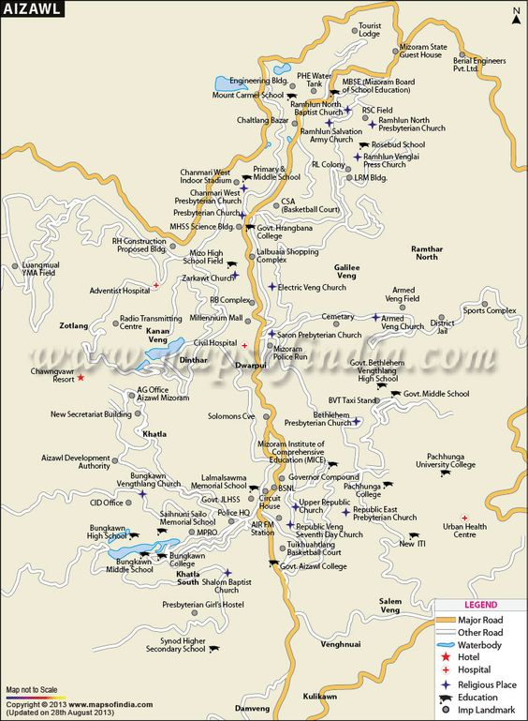

Map of Aizawl

1.3 OBJECTIVES:
- To find out the source from where their get Tomato?
- To find out the rate their get Tomatoes and the rate to sell out their customers?
- To find out that the city can be self sufficient in Tomato?

3.5 Waste /Post Harvest Management :

The main problems faced by the vendors are that the tomatoes are decayed within a short period of time, and this decay rate was increased due to the absence of availability of cold storage for the vendors to store the tomatoes which could prevent the tomatoes from decaying and would be able to store them for longer period of time. As the tomatoes are decayed easily, the sellers or vendors had to sell it in a cheaper rate and some were used for their family consumption as well as a food for animals, which would result in a less profit for the vendors. Usually, every box of tomatoes contain about 2-3 kg of waste tomatoes, which are not suitable for sale. Thus, the vendors would be able to sale about 25-26 kg of tomatoes out of which a box containing 28 kg of tomatoes. As the tomatoes are imported and were sold in the market, they have to be transported by vehicles, they were sometimes crashed due to the problems along the routes , this would also cause an increase of waste besides the decaying of tomatoes. Therefore, these problems would reduce the profit rates of vendors.

