SRI LANKA INSTITUTE OF ADVANCED TECHNOLOGY

EDUCATION

**JOLLY BEEZ ONLINE RESTAURANT MANAGEMENT SYSTEM**



ADVANCED TECHNOLOGICAL INSTITUTE ANURADHAPURA

SUPERVISOR: MRS.D.K.Y. DHARMAWARDHANA

NAME: MOHAMMED SHFAQ FATHIMA SHAHDHA STUDENT NUMBER: ANU/IT/2022/F/61

COURSE: HIGHER NATIONAL DIPLOMA IN INFORMATION

TECHNOLOGY

YEAR: 2022(1ST YEAR FIRST SEMESTER

Table of Contents

|  |  |  |
| --- | --- | --- |
| i. Title |  | 3 |
| ii. Introduction |  | 3 |
| iii. Background |  | 4 |
| iv. Problems in Brief |  | 5 |
| v. Aims and Objectives |  | 6 |
| v. I. Aims |  | 6 |
| v. ii. Objectives |  | 6 |
| vi. Proposed Solution |  | 7 |
| Vi. Use Case Diagram |  | 10 |
| vii. Resource Requirements |  | 11 |
| * 1. Hardware Requirements   2. Software Requirements | 11 | 11 |
| viii. References |  | 12 |

# Title

**jollybeez online restaurant management system**

# Introduction

This project proposal is submitted to meet the software development requirements of the individual project module conducted by the Sri Lanka Institute of advanced technological Education. (SLIATE)

Information Technology has revolutionized the life of human beings and has made lives easier through various kinds of applications. In light of the rapid changes in the use of Information Technology This project is concerned with developing a Jollybeez online restaurant System to make Restaurant management more efficient and easier to handle. Many tools, technologies and systems have been produced and invented. This Restaurant management system enables a fully automated Restaurant service. It can display the details of the food items available in this Restaurant. Furthermore, it can be able track the transactions between customers and vendors. The goals of this project are to provide simplicity, security, and efficiency to the Restaurant's management and reduce managing staff in the Restaurant. This restaurant opened 24 hours.

## Background

This restaurant system of mine is done manually.

In this, a register is kept for recording the room booking of the customers and the record of the room cancelers is kept in the register kept for the same.

And the details of customers ordering food will also be recorded in the register.

many restaurants have a lot difficult to manage the business such as customer ordering and reservation table. If the customer book an order and later wants to cancel the order, he is permitted to do this only within a specific time period.

By using manual customer ordering it is difficult for the waiter to keep the correct customer information and may lose the customer information. The

customer is also given the facility to view the status of the order to determine if it is ready.

Online Restaurant management system is the system for manage the restaurant business. After successful login the customer can access the menu page with the items listed according to the desired time. The main point of developing this system is to help restaurant administrator manage the

restaurant business and help customer for online ordering and reserve table. In proposed system user can search for a menu according to his choice i.e.,

according to price range and category of food and later he can order a meal.

## Problems in Brief

Their process is currently manual and time consuming. Customer cannot order food online, before they visit the restaurant. They have to visit the restaurant and place the order. Then they have to wait until the order is ready.

There is no visual confirmation that the order was placed correctly. Customers cannot ensure about the correctness of their order. Order customization is also difficult because it takes more time. Table reservation is also difficult. This restaurant is very busy in the morning and evening after 6 pm because the restaurant is located

in a very attractive place, near the beach. Therefore, the restaurant is always full. Currently customers have to come to the restaurant to reserve a table. Sometimes customers have to wait long time to reserve a table during busy times. Also, very long queues are there. It is difficult for the cashier to handle such a situation. On the other hand,

this situation is difficult for the kitchen also. They are receiving orders one by one. Sometimes kitchen is receiving same food item within separate orders in same time. So, kitchen has to make them separately. This is time consuming and inefficient costly method. It is better if the orders for same kind of food are grouped. It will help them to save time and attend to the next order quickly.

At the end of the day, taking a summery is also difficult because there are so many orders and they are not recorded properly. This happens because they are not keeping records properly. Taking this summary is important because they can review what the fast-moving items are and what items are not ordered frequently. Sometimes customers do valuable suggestions. Usually, staff is listening to them and try to do the improvements. But they are not keeping records of those suggestions and they may forget them at the end of the day. It is not good for the restaurant because it will break the trust of the customer and missing the opportunity for the improvement. Currently, this restaurant uses least efficient methods such as paper-based or verbal method to communicate between the restaurant and kitchen. Even though this approach is implemented in successful profitable restaurants, there are several problems which could be seen as reducing the restaurant's efficiency that can be identified using above scenario:

Sometimes handwriting can lead to miscommunication.

Order logging is unmanageable.

Inefficient restaurant-kitchen communication.

Difficult order tracking and time management.

Difficult stock management.

Online system that proposed here will simplify the ordering process and it will be helpful to both

restaurant and customer. The proposed system will be developed with interactive menus, pop-up

messages etc. for the easiness of the user. Customer can select the required food item with available

customizations and the can change the order at any time before checking out online. If order is

confirmed, it will display a pop-up message as confirmation to the customer. When the order is

placed it's recorded in the database and retrieved in real time manner. Through this option

Restaurant Employees are allowed to quickly go through the orders which they have received.

Therefore, they can process all orders efficiently and effectively with minimal delays and confusion.

## Aims and Objectives

v. i. **Aims**

The aim of my project is to This application is developed so that the customer can easily fill the order.

1. ii. **Objectives**
   * To create a system that will handle hotel management.
   * To provide a centralized platform for storing food order amount records.
   * To send food order amount information to registered customers via electronic means.
   * To create a system that allows food suppliers to manage.
   * To assess user acceptability, functionality, efficiency, productivity, quality portability, and dependability of the system
   * To develop a system that will surely satisfy the customer service
   * To design a system able to accommodate huge amount of orders at a time

## Proposed solution

The proposed solutions fulfil the problems faced by the users of this system. General solutions for the problem,

* The basic need of software is to save the time of the user with the help of all useful information.
* It is maintaining the collection of data in your computer systematically. So that it’s easy to understand.
* The proposed system provides many facilities to the user to store information about the Customers and the staff, and it provides information quickly in a systematic manner.
* The processing time on data is very fast.
* It provides required data quickly to the user and also in a specified manner to the user.

## Methodology

**Home page**

This is the first page.

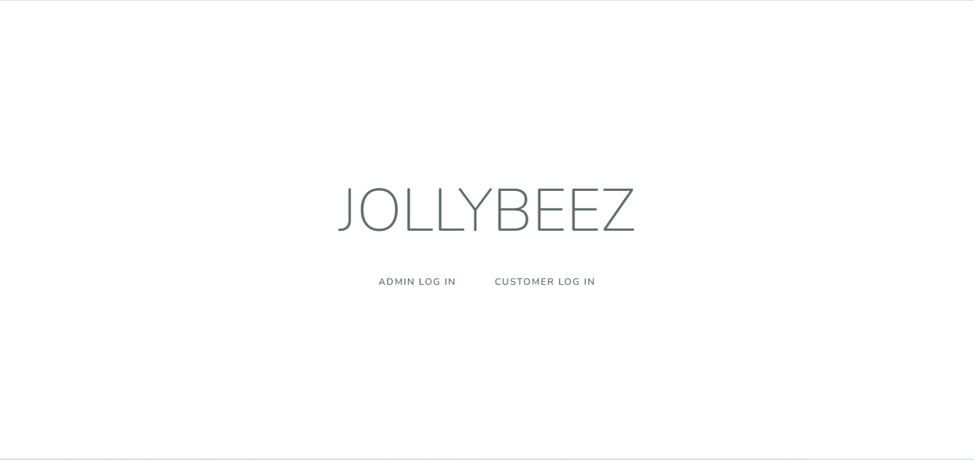

**Login page**

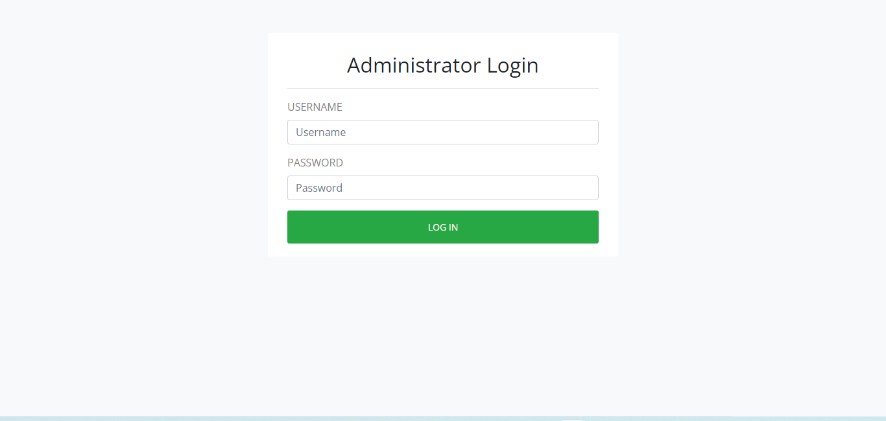



First go to our web site and click login button



Then you have an already



Account type yoour email and password



Than click login button than order your food

**Register page.**

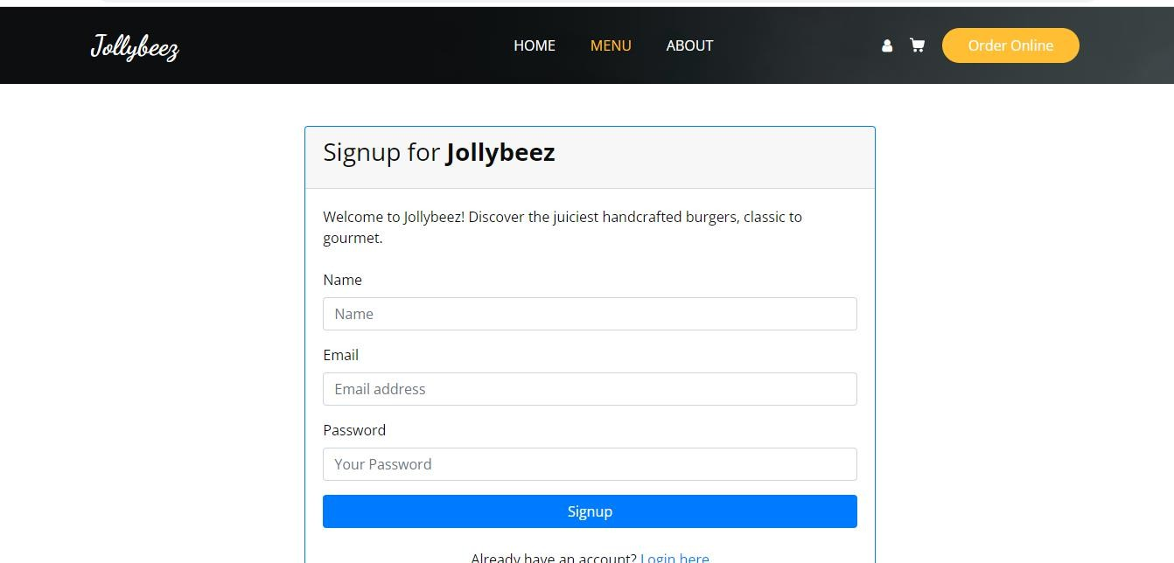



You haven’t account fill register form and click



Register button after go to login page and



Type your email and password



Then go to the main page and order



Your favorite food

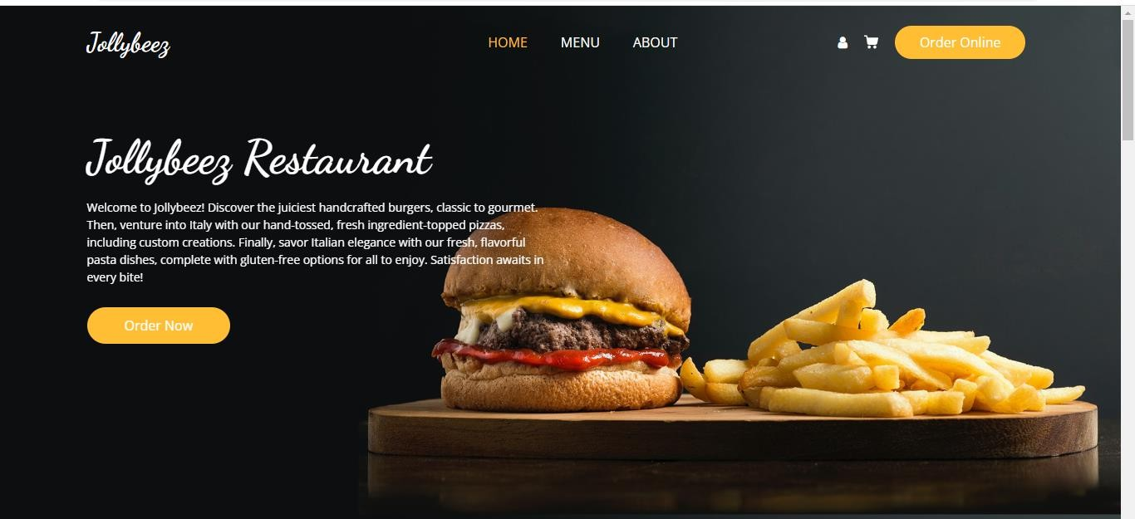

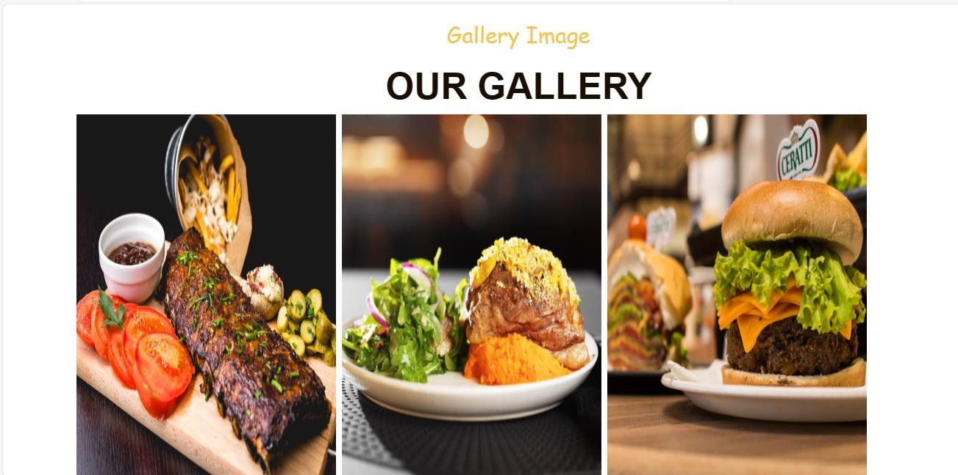



This is your main page that page you will see all category check our dedails and give your



Feedback





This is our food gellary you want to any food click add to cart and go to cart and click



Paynow than your payment success than receive your food at home

**vi .i. Use Case Diagram**

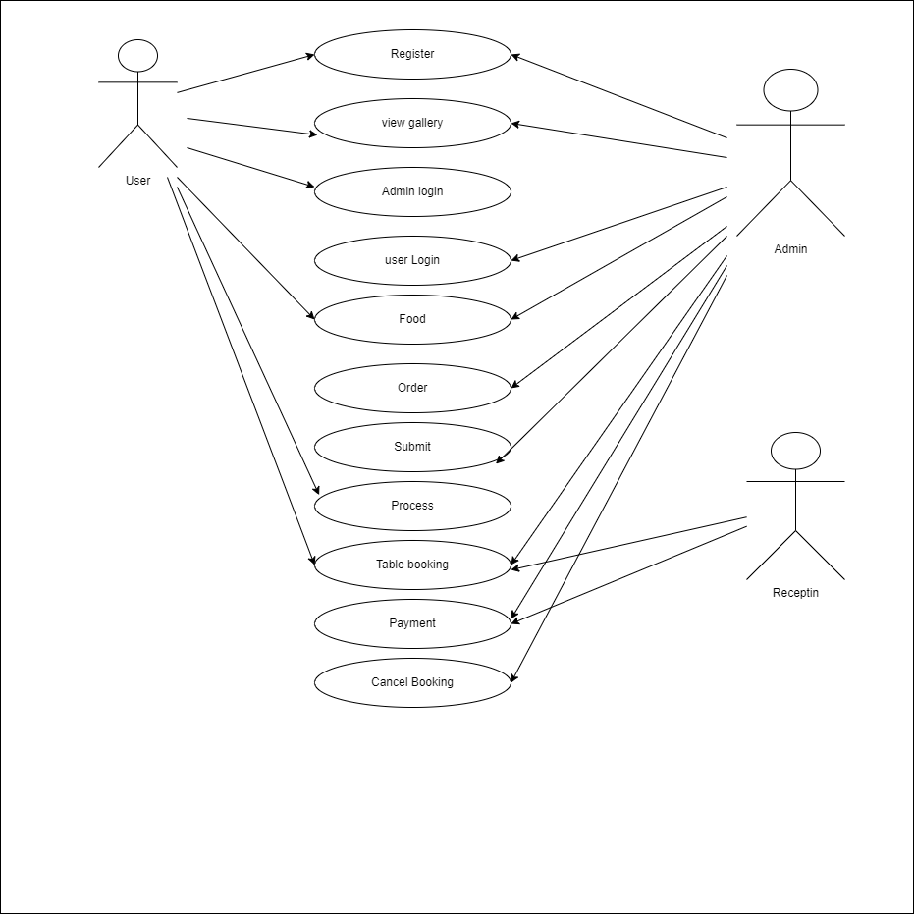

## Resource requirements

* 1. **Hardware Requirements**
     + Processor - Intel core – i5
     + Processor - 2.0 GHz
     + Hard Drive – 256GB

Vii .ii **Software Requirements**

* + - Operating System: Windows 11.
    - Latest Web Browser

References

|  |  |
| --- | --- |
| [1] | "php code," w3school. |
| [2] | "mysql," w3school. |
| [3] | "Desgin," [www.google.com.](http://www.google.com/) |