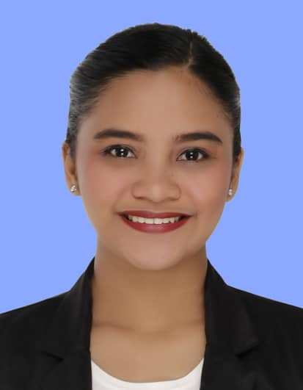

**Katrina Keith R. Mallannao**

#2D9 GSIS Building 6 Pureza Street Santa Mesa Manila

**Mobile Number**:+639-65483-2613

**Email Address**:katrinakeithr@gmail.com

**AREER OBJECTIVE:**

Seeking for a position in the field of Hospitality management as a gateway to a meaningful career and to developed my skills and become globally competitive.

**PERSONAL INFORMATION:**

Date of Birth : September 17, 1997

Place of Birth : San Mateo, Isabela

Civil Status : Married

Gender : Female

Religion : Roman Catholic

Height : 5’6’’

Weight : 58 kg

Father’s Name : Ronald P. Remigio

Occupation : Farmer

Mother’s Name : Jocelyn D. Remigio

Occupation : House Wife

**EDUCATIONAL ATTAINMENT:**

**Tertiary Education:**

Bachelor of Science in Hotel and Restaurant Management (BSHRM)

University of La Salette, Inc.

Santiago City, Isabela

2013-2017

**Secondary Education:**

La Salette of San Mateo

Brgy. 1 San Mateo Isabela

2009-2013

**Primary Education:**

Sinamar Norte Elementary School

Sinamar Norte, San Mateo, Isabela

2003-2009

**SKILLS AND ABILITIES**

* Customer Service Skill
* Communication Skill
* Computer Knowledge
* Multitasking and willing to work under pressure
* Gaming Rules
* Deal the game according to standard rules

**Training/s and Seminar/s Attended**

* On the Job Training at Astoria Plaza Hotel (600 Hours)

15 Escriva Dr, Ortigas Business District, Pasig, 1600 Metro Manila

December 08, 2016 to

February 19, 2017

* National Certificate II in Front Office

Technical Education and Skills Development

October 11, 2015

* National Certificate II in Housekeeping

Technical Education and Skills Development

March 03, 2015

**Work Experience**

* SUMMER PALACE – EDSA SHANGRI-LA HOTEL

Service Associate

1 Garden Way, Ortigas Centre, Mandaluyong City

June 2017 – February 2018

* Ace Water Spa

Receptionist

399 Del Monte Avenue,near cor.Banawe St.,SFDM,Quezon City

April 2018- April 2019

* Resorts World Manila

Casino Dealer

Newport City Pasay City Manila

May 29,2019-Present

* Resorts World Manila

Service Ambassador (Call ins)

Newport City Pasay City Manila

October 05,2020- March 27, 2021

**CHARACTER REFERENCES**

* Mr. Noel Mendiola

Operations Manager at Summer Palace Restaurant

EDSA Shangri-La Hotel

+639-1787- 67116

* Ms. Jasmin Valle

Operational Supevisor

Ace Water Spa

**+**639-4539-89194

* Christopher Pasco

Pit Manager

Resort World Manila

+639-0622-77911

* Marr Olegario Magat

Food and Beverage Supervisor

Resorts World Manila

+639-2777-18609

I hereby certify that all the above information is true and correct to the best of my knowledge and belief.

**KATRINA KEITH R. MALLANNAO**

Applicant