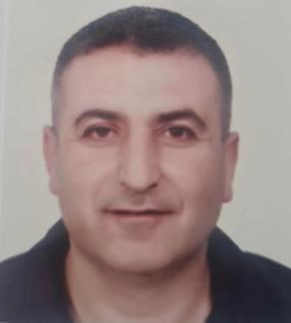
Fouad Mohammad Mazloum
Cash Van Sales 1-2-1974 _______________________________________

Talya, Baalbek, Beqaa-Hermel Governorate +96103382350 @fouad03382350@gmail.com

……………………………………..Professional Summary……………………………………

I am a hard worker with good communication skills. I am looking for a new challenge where I can use my existing skills and further develop my career. My ambition is to contribute to the society. I am prepared with lots of knowledge. I am skillful, tolerant, and reliable.

……………………………………………Skills………………………………………………….

Languages: English , Arabic (mother tongue).
Strength:Teamwork, Able to work under pressure, Easy adaptation and merging into society, Traveling, Reading,and Knowing different human cultures.
Computer:Microsoft excel,Microsoft word,Microsoft powerpoint. +using the hand held and the printer.
………………………………………….Education………………………………………………

Al-Iman Secondary School , Barital Campus

………………………………………….Experience……………………………………………

Cash van sales at “Sohat Distribution” ,Nestle Waters in Lebanon from 1-7-2004 till 2-1-2023 . Cash van sales at “Canis Trading Company (CTC)” from 15-3-2023 and I am still working.
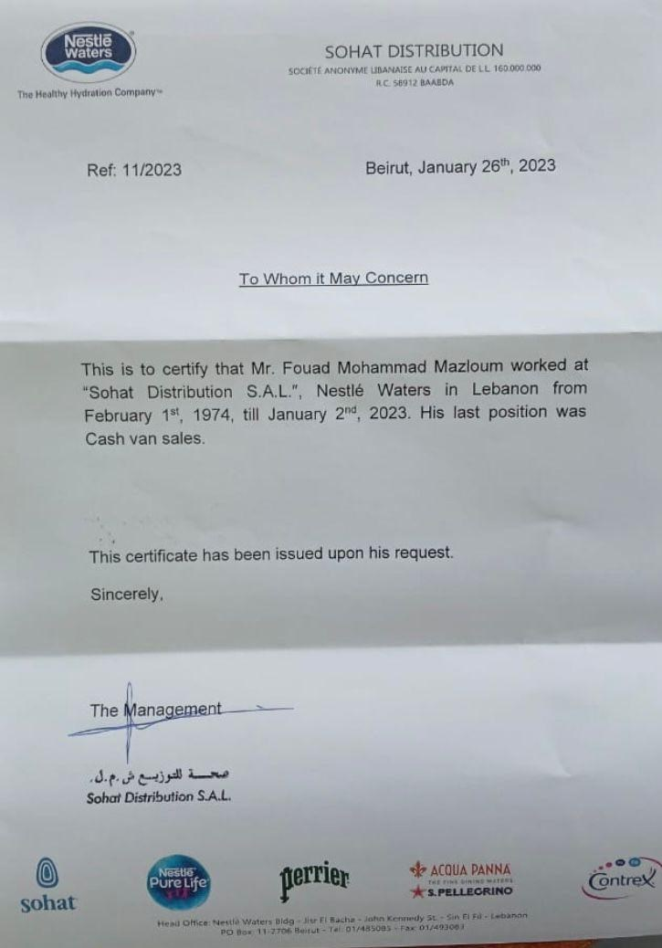
Your license is obsolete and can't work with this version.
This is the newest PDF Focus .Net version 7.7.7.24.
Click here to update your license!

