**Date 9th, March 2022**

**Sales & Purchase Agreement**

**First Party (SELLER):**

**LLD**. Independent Consultant PhD, ========= Passport Number 0000000000 with Expiry Date: 0000, 000000

**Second Party (BUYER):**

**TO BE ADDED**

The Seller agrees to sell, and the Buyer agrees to buy the Diamond Necklace as per the terms & conditions:

**1) Product**

Diamond Necklace as mentioned in GIA report number 15748393, dated on 28th February 2007. That is Emerald Cut, weighting 102.11 Carats, Color Grade L, and Clarity Grade VS2. Additionally, identified in HRD Antwerp Institute of Gemology Certificate No. 09017066001, dated on 24th September 2009. The necklace comes with Two Earrings 1- GIA report number 5202666778, dated 21st October 2019, which is Emerald Cut, Color Grade M, and Clarity Grade VS1, and Weighting 30.57 Carats. 2- GIA report number 2205666757 dated 17th October 2019. That is Emerald Cut, Color Grade M, and Clarity Grade SI1, and Weighting 30.56 Carat. The necklace and two earrings weigh a total of 434.46 carats.

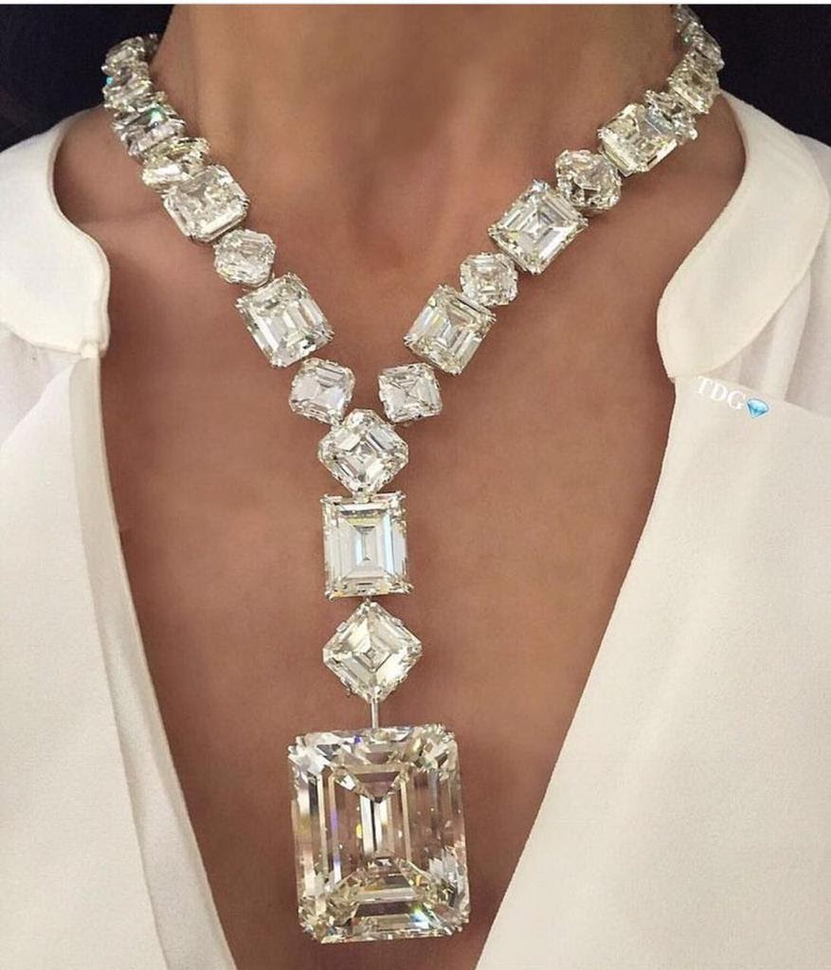

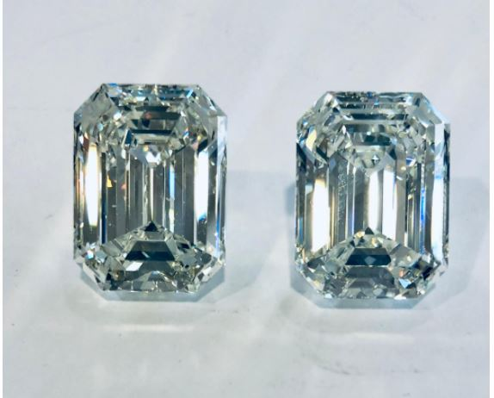

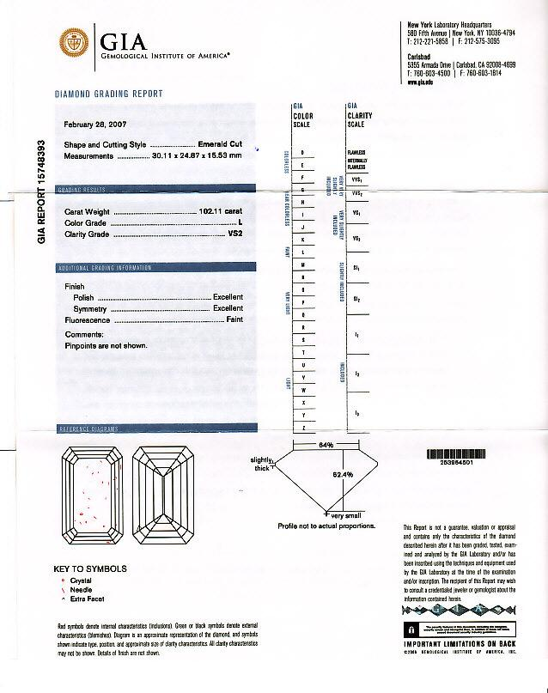

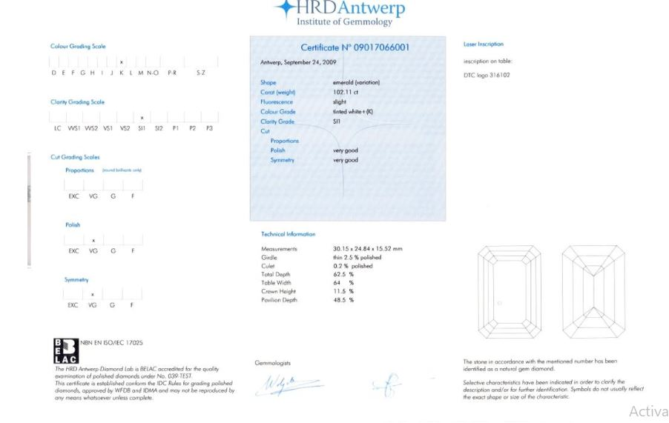

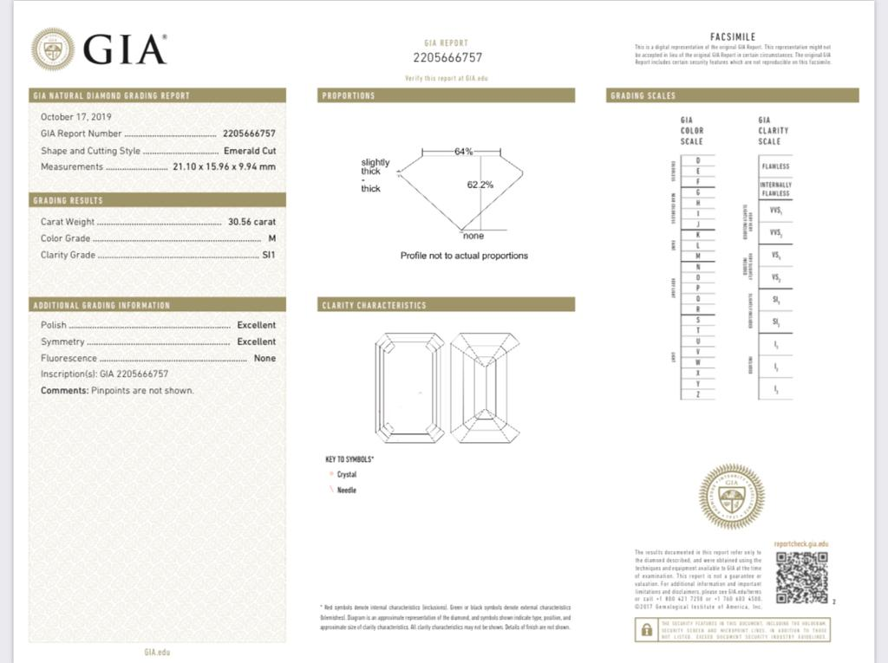

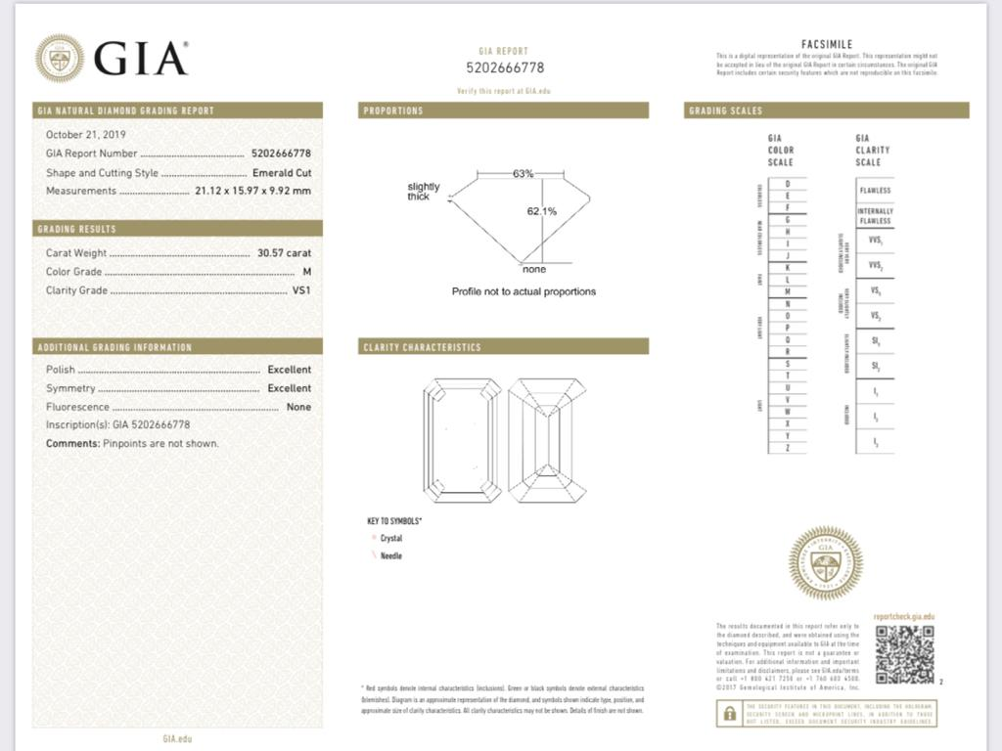

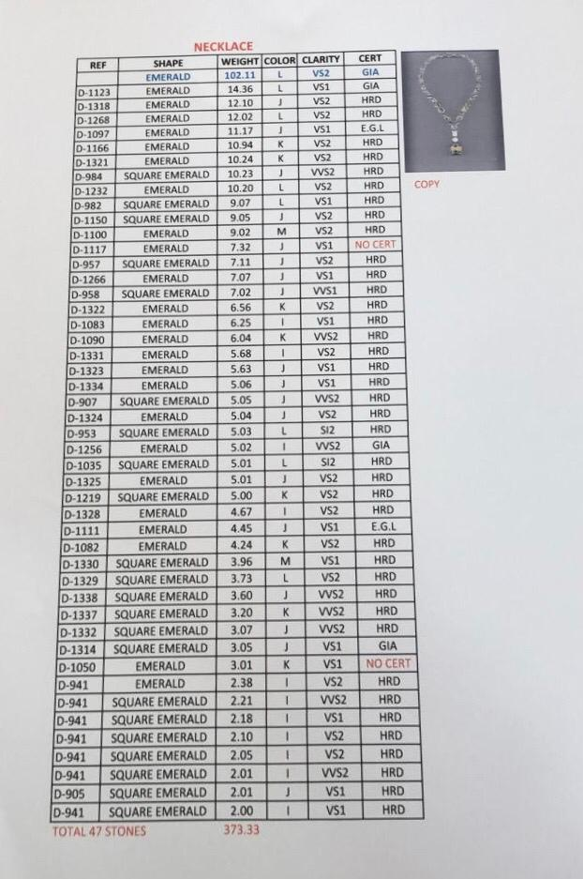

**2) Price**

Thirty Five Million Thousand United Stated Dollars (35,000,000.00 $).

Buyer has the right / option to make the payment of the purchased Diamond Necklace in United Arab Emirates Dirhams.

**3) Buyer Representative**

Both parties agree that the Buyer will send his representative to Dubai, The United Arab Emirates to physically inspect the Diamond Necklace and earrings as per the full specification mentioned in the GIA report number 15748393, dated on 28th February 2007.

**4) Method of payment:**

Manager cheque in advance issued to the name of (SELLER). The buyer is to provide the seller with a copy of such cheque to prove willingness and ability to buy. Afterwards, both parties are to meet in Dubai with the original cheque available to be authenticated directly with the issuing bank or the correspondent bank. Once the cheque is cleared, the buyer solely or a representative with their gemologist can inspect the necklace and earrings to ensure if they are in accordance with the provided certificate and specifications. Upon completion of the inspection and proving that all specifications are true and accurate, the buyer is obligated to provide the seller with the original cheque. At this point in the transaction, the buyer is not able to back out of the deal and cause any delays.

**5) Third Party Inspection If the Buyer wants:**

Both Parties agree that the Diamond Necklace could be inspected by Dubai Municipality (**The International Gemological Institute (IGI) – Dubai)** in presence of the Buyer representative.

**Seller**

**D**ate 9th, March 2022

**Buyer**

Name

Signature

Date

**Electronic signature is accepted.**