WIND TURBAIN

A wind turbine is a device that converts the kinetic energy of wind into mechanical energy, which is then used to generate electricity. It consists of a tall tower, usually made of steel or concrete, with large blades attached to a rotor at the top. When the wind blows, it causes the blades to rotate, which in turn rotates the rotor connected to a generator. The generator converts the mechanical energy of the rotating rotor into electrical energy. This electricity can be used to power homes, businesses, or even be fed into the grid for distribution. Wind turbines are commonly used in wind farms, where multiple turbines are installed together to harness the power of wind on a larger scale. They are considered a renewable energy source and help in reducing greenhouse gas emissions

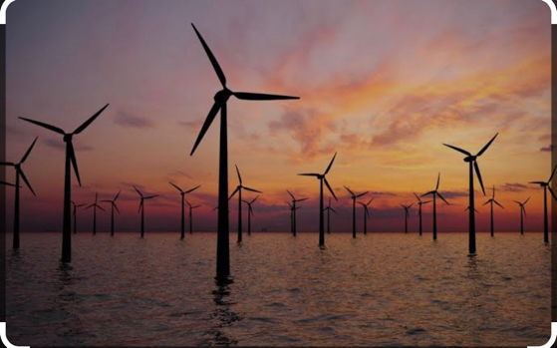

WIND TURBAIN DIAGRAM

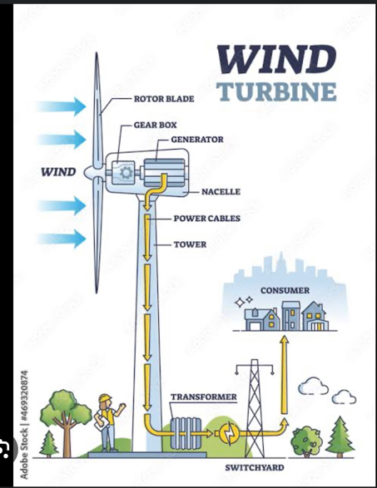

WHO IS THE INNOVATOR WIND TURBAIN

The invention of the wind turbine is not attributed to a single innovator, as it has evolved over centuries with contributions from various individuals and cultures. The earliest known use of wind power dates back to ancient Persia and China, where windmills were first developed for tasks such as grinding grain and pumping water.

However, modern wind turbines as we know them today were developed and refined by several innovators and engineers. Some notable individuals in the history of wind turbine technology include:

\* Charles F. Brush: In the late 19th century, Brush designed the first large-scale windmill specifically built to generate electricity. His design incorporated a tower, a rotor with several blades, and a generator.

\* Poul la Cour: A Danish scientist and meteorologist, la Cour made significant contributions to wind turbine technology in the early 20th century. He conducted extensive research on wind turbine design and was instrumental in promoting wind power for electricity generation.

\* Johannes Juul: A Danish engineer, Juul improved upon previous wind turbine designs and introduced important concepts such as yaw control and aerodynamic blade profiles. His work laid the foundation for modern wind turbines.

\* Earl L. Jensen: An American engineer, Jensen developed the concept of the propeller-type wind turbine in the 1930s. His design featured a three-bladed rotor that is still widely used today.

\* German innovators: In the 1980s, German engineers and researchers made significant advancements in wind turbine technology. They pioneered the development of gearless, direct-drive turbines, which improved efficiency and reduced maintenance.

These are just a few examples of the numerous innovators and contributors who have played a role in the development of wind turbine technology throughout history. Wind power technology continues to advance, with ongoing innovations and improvements by engineers and scientists worldwide.

WHAT MATERIALS & TOOLS ARE USED TO DEVELOP IT

Materials:

1. Steel or aluminum for the tower and nacelle

2. Fiberglass or carbon fiber for the blades

3. Copper for the generator coils

4. Neodymium magnets for the generator

Tools:

1. Welding equipment for assembling the tower and nacelle

2. CNC machines for shaping and finishing the blades

3. Electrical equipment for wiring and connecting the generator

4. Crane or lifting equipment for installation of the turbine components

To develop a wind turbine, the following steps can be taken:

\* Planning and Design:

\* Determine the power requirements and goals for the wind turbine.

\* Conduct a site analysis to identify the average wind speed and direction.

\* Select the appropriate turbine size based on energy needs and available space.

\* Design the turbine components, such as blades, rotor, tower, and generator.

\* Procuring Materials and Tools:

\* Identify and procure the required materials, which may include:

\* Rotor blades: Typically made of fiberglass, carbon fiber, or composite materials.

\* Tower: Steel or concrete structures.

\* Nacelle: Housing for the generator and control systems.

\* Generator: Depending on the design, this can be an off-the-shelf unit or a custom-built one.

\* Acquire the necessary tools, such as welding equipment, cutting tools, and electrical instruments.

\* Fabrication and Assembly:

\* Cut and shape the rotor blades according to the design.

\* Construct the tower and assemble the necessary platform for the nacelle.

\* Install the generator, control systems, and electrical components.

\* Connect the rotor blades to the hub and mount the entire assembly on top of the tower.

\* Testing and Calibration:

\* Conduct initial tests to ensure proper alignment, balance, and functioning of the wind turbine.

\* Evaluate the performance of the turbine under different wind conditions.

\* Adjust and calibrate the turbine settings to optimize energy generation and efficiency.

\* Installation and Operation:

\* Install the wind turbine on a suitable site, taking into consideration safety, wind accessibility, and local regulations.

\* Connect the turbine to the electrical grid or an off-grid energy storage system.

\* Monitor the turbine performance, maintenance requirements, and safety measures regularly.

\* Troubleshoot and address any issues that may arise during the operation.

It is important to note that the development process for wind turbines can vary depending on the specific design, scale, and requirements. It is advisable to consult with experts and professional engineers to ensure proper development and installation of a wind turbine.

WHAT ARE THE BENEFITS AND FUNTION OF WIND TURBAIN

BENEFITS :-provides electricity without burning any fuel or polluting the air. Wind continues to be the largest source of renewable power

•Wind energy projects attract jobs, increase tourism, and provide a revenue source for farmers and ranchers

FUNTION:-they use the power of the wind to create electricity

WHO ARE THE POTENTIAL USERS WIND TURBAIN

The potential users of wind turbines include:

1. Utility companies and energy providers looking to diversify their energy mix and reduce carbon emissions.

2. Governments and policymakers seeking to promote renewable energy and reduce dependence on fossil fuels.

3. Businesses and industries looking to invest in clean energy and reduce their environmental impact.

4. Communities and landowners interested in leasing their land for wind turbine projects and benefiting from the economic opportunities they provide.

5. Individuals and households looking to support clean energy and reduce their carbon footprint by purchasing wind-generated electricity.