Trigonometric Identities and Equations
Exact Trigonometric Values

You will frequently encounter angles of $30°, 60°, 45°$ in geometric problems.
Although you will always have a calculator, you need to know how to derive these.
All you need to remember:
Draw half a unit square and half an equilateral triangle of side 2.

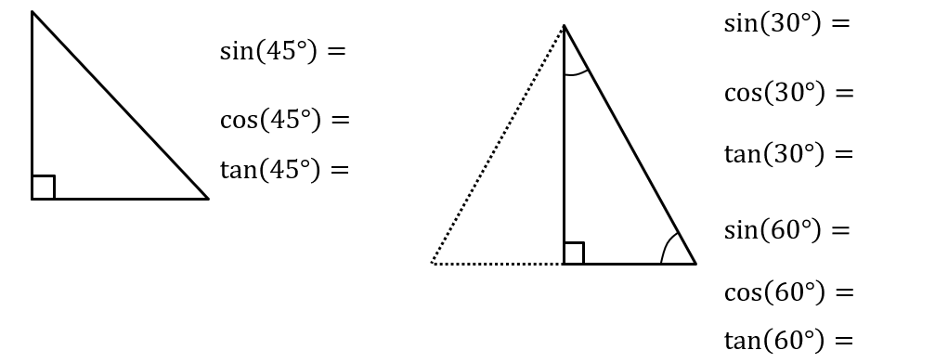

For values of $θ$ in the range $0<θ<90°$, you know that $\sin{θ}$ and $\cos{θ}$ are lengths on a right-angled triangle:

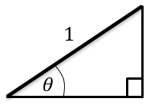

And what would be the gradient of the bold line?

The point $P$ on a unit circle, such that $OP$ makes an angle $θ$ with the positive $x$-axis, has coordinates $\left(\cos{θ},\sin{θ}\right)$.
$OP$has gradient $\tan{θ}$.

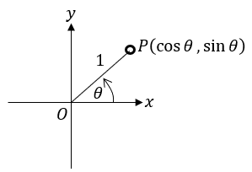

Use the unit circle to determine each value in the table, using either “0”, “+ve”, “-ve”, “1”, “-1” or “undefined”. Recall that the point on the unit circle has coordinate $(\cos{θ},\sin{θ})$ and $OP$ has gradient $\tan{θ}$.

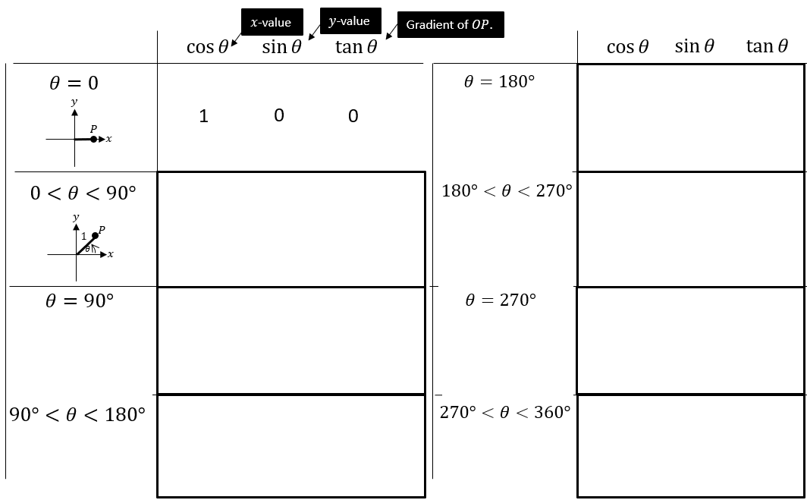

The unit circles explains the behaviour of these trigonometric graphs beyond $90°$.
However, the easiest way to remember whether $\sin\left(x\right),\cos\left(x\right),\tan\left(x\right)$ are positive or negative is to just do a very quick sketch (preferably mentally!) of the corresponding graph.

GeoGebra:
https://www.geogebra.org/m/UjjwuM8p

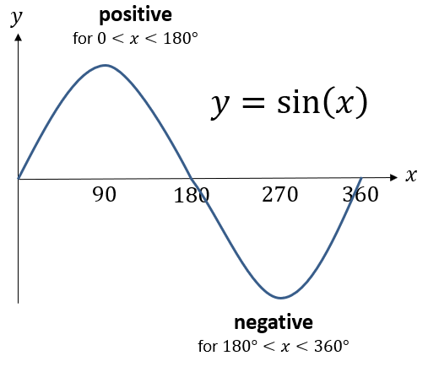

The following are all easily derivable using a quick sketch of a trigonometric graph and are merely a convenience, so you don’t always have to draw out a graph every time.
You are highly encouraged to memorise these so that you can do exam questions faster.

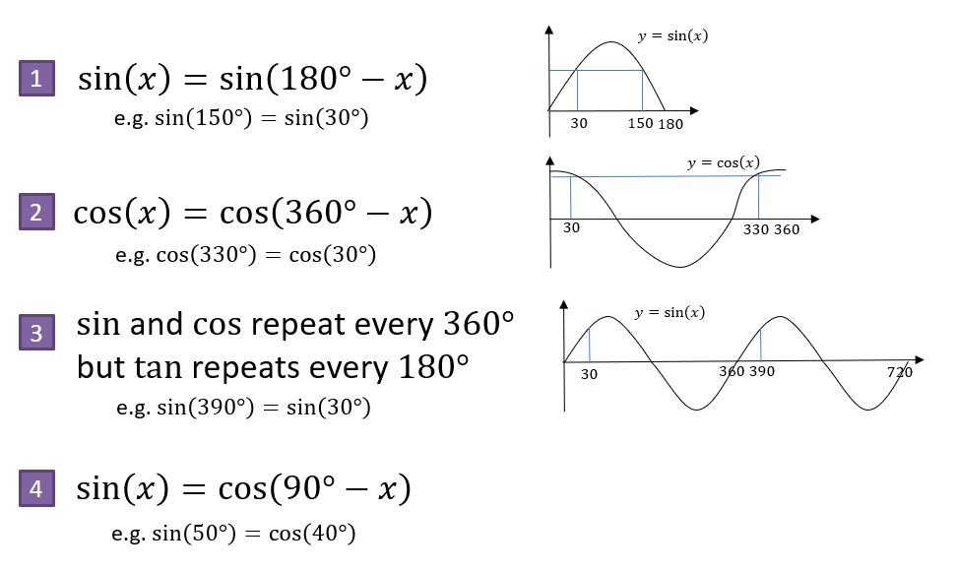

Examples:
Without a calculator, work out the value of each below.
$$\tan\left(225°\right)$$

$$\tan\left(210°\right)$$

$$\sin\left(150°\right)$$

$$\cos\left(300°\right)$$

$$\sin\left(-45°\right)$$

$$\cos\left(750°\right)$$

$$\cos\left(120°\right)$$

Test Your Understanding:
$$\cos\left(315°\right)$$

$$\sin\left(420°\right)$$

$$\tan\left(-120°\right)$$

$$\tan\left(-45°\right)$$

$$\sin\left(135°\right)$$

Reflections: It’s not hard to see from the graph that in general, $\sin\left(-x\right)=-\sin\left(x\right)$.
Even more generally, a function $f$ is known as an ‘odd function’ if $f\left(-x\right)=-f(x)$.
$tan$ is similarly ‘odd’ as $\tan\left(-x\right)=-\tan\left(x\right)$.
A function is even if $f\left(-x\right)=f(x)$. Examples are $f\left(x\right)=cos⁡(x)$ and $f\left(x\right)=x^{2}$ as $\cos\left(-x\right)=cos⁡(x)$ and ${\left(-x\right)}^{2}={\left(x\right)}^{2}$. You do not need to know this for the exam.

Exercise 10A (pages 207-208)
Lots of students do find using CAST diagrams quite useful and prefer this method over using the graphs. You might find it useful to read through the examples and answer the questions in this exercise, but if this is the method you wish to use then you should do all the questions to ensure you are confident in applying this approach.

Exercise 10B (page 209)
This is a very short exercise that should be completed regardless of which approach you choose to use to find equivalent trigonometric ratios.
Trigonometric Identities and Equations
Trigonometric Identities

Returning to our point on the unit circle…
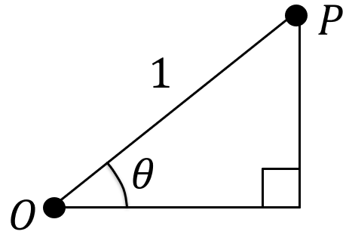

We get two identities:

Example:
Prove that $1-\tan{θ}\sin{θ}\cos{θ}≡\cos^{2}{θ}$

Example:
Prove that
$$\tan{θ}+\frac{1}{\tan{θ}}≡\frac{1}{\sin{θ}\cos{θ}}$$

Example:
Simplify $5-5\sin^{2}{θ}$

Test Your Understanding:
Prove that
$$\frac{\tan{x}\cos{x}}{\sqrt{1-\cos^{2}{x}}}≡1$$

Test Your Understanding:
Prove that
$$\frac{\cos^{4}{θ}-\sin^{4}{θ}}{\cos^{2}{θ}}≡1-\tan^{2}{θ}$$

Test Your Understanding:
Prove that
$$\tan^{2}{θ}≡\frac{1}{\cos^{2}{θ}}-1$$

Example:
Given that $\cos{θ}=-\frac{3}{5}$ and that $θ$ is reflex, find the value of $\sin{θ}$

Exercise 10C (pages 211-212)
This is a valuable exercise and care should be taken to complete all the questions.

Extension:
[MAT 2008 1C] The simultaneous equations in $x,y$,
$$\left(\cos{θ}\right)x-\left(\sin{θ}\right)y=2\left(\sin{θ}\right)x+\left(\cos{θ}\right)y=1$$
are solvable:
- for all values of $θ$ in range
$0≤θ<2π$
- except for one value of $θ$ in range $0≤θ<2π$
- except for two values of $θ$ in range $0≤θ<2π$
- except for three values of $θ$ in range $0≤θ<2π$
Trigonometric Identities and Equations
Solving Trigonometric Equations

Example:
Solve $\sin{θ}=\frac{1}{2}$ in the interval $0≤θ≤360°$.

Example:
Solve $5\tan{θ}=10$ in the interval $-180°≤θ<180°$

Example:
Solve $\sin{θ}=-\frac{1}{2}$ in the interval $0≤θ≤360°$.

Example:
Solve $\sin{θ}=\sqrt{3}\cos{θ}$ in the interval $0≤θ≤360°$.

Test Your Understanding:
Solve $2\cos{θ}=\sqrt{3}$ in the interval $0≤θ≤360°$.

Test Your Understanding:
Solve $\sqrt{3}\sin{θ}=\cos{θ}$ in the interval $-180°≤θ≤180°$.

Exercise 10D (pages 215-216)
Another valuable exercise – you should certainly answer all of questions 3-11.
Trigonometric Identities and Equations
Solving Harder Trigonometric Equations

Harder questions replace the angle $θ$ with a linear expression.

Example:
Solve $\cos{3x=-\frac{1}{2}}$ in the interval $0≤x≤360°$.

Example:
Solve $\sin{(2x+30°)=\frac{1}{\sqrt{2}}}$ in the interval $0≤x≤360°$.

Example:
Solve $\sin{x}=2\cos{x}$ in the interval $0≤x<300°$

Test Your Understanding:
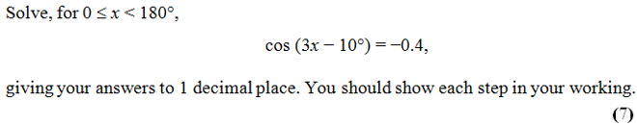

Exercise 10E (pages 218-219)
You guessed it, another valuable exercise and you should complete all the questions.
Trigonometric Identities and Equations
Equations and Identities

We saw that an equation can be ‘quadratic in’ something, e.g. $x-2\sqrt{x}+1=0$ is ‘quadratic in $\sqrt{x}$’, meaning that $\sqrt{x}$ could be replaced with another variable, say $y$, to produce a quadratic equation $y^{2}-2y+1=0$.

Example:
Solve $5\sin^{2}{x}+3\sin{x}-2=0$ in the interval $0≤x≤360°$.

Example:
Solve $\tan^{2}{θ}=4$ in the interval $0≤θ≤360°$.

Example:
Solve $2\cos^{2}{x}+9\sin{x}=3\sin^{2}{x}$ in the interval $-180°≤x≤180°$.

Test Your Understanding:
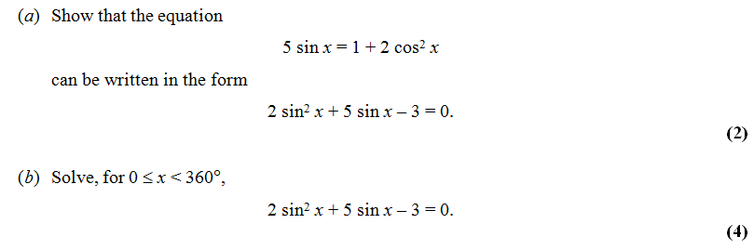

Exercise 10F (pages 221-222)
…another valuable exercise (!) and you should complete all the questions.

Extension:
[MAT 2010 1C] In the range $0≤x<360°$, the equation
$$\sin^{2}{x}+3\sin{x}\cos{x}+2\cos^{2}{x}=0$$
Has how many solutions?

[MAT 2014 1E] As $x$ varies over the real numbers, the largest value taken by the function
${\left(4\sin^{2}{x}+4\cos{x}+1\right)}^{2}$ equals what?

Mixed Exercise 10 (pages 222-224)
Answer the odd numbered questions from this exercise now. We can complete the even numbered questions for revision.

