|  |  |
| --- | --- |
|  | **Writing Assignment Checklist and worksheet** |
| * 🗸 | * **Instructions:** After you complete this Writing Assignment, place a **check mark next to each of the five (5) numbers below.** There is **no page requirement**. There is **no correct answer**. Your answers should be based on your thoughts, opinions, and ideas. * You will be assessed based on your ability to: a) carefully **read,** b) critically **think**, and c) **write** detailed and relevant response(s). * You will answer each question based upon your: 1) own **thoughts, opinions, ideas and experiences**, 2) review of the **Selected Readings** in the hyperlinks, and 3) your ability to **analyze information** related to the Introduction to Sociology course. * Make sure to subscribe to The New York Times for FREE. Go to NYTIMES- Complimentary Access at <https://www.lib.jjay.cuny.edu/nyt> * Each Question has a **hyperlink** (Selected Reading and/or website) that is provided to help you in preparing and writing your answer. * **If a hyperlink does not work**, cut and paste the word(s) of the article into the search engine for Google. |
|  | 1. Make sure your Assignment is **typed** directly into this template. |
|  | 1. Make sure to include **your full name and a picture** (a Selfie is fine) on the first page. Make sure the picture is acceptable for an internship and/or other related related academic environment. |
|  | 1. Make every effort to write **detailed answers in paragraph format** directly into this template under the question. |
|  | 1. Each question requiring an explanation should have at a **minimum, one paragraph**. Yes, you definitely may write more than one paragraph for each answer. |
|  | 1. Make sure you go to SAVE AS and save your document as a Word document (docx) or (.doc) and NOT PAGES (or a PDF). After submitting your assignment to Blackboard, double-check to make sure the document is a Word document with an extension (.docx) or (.doc) NOT (.PDF) and NOT PAGES. |
|  | 1. Post your completed Sociological Bio on Blackboard and into the SafeAssign module by 12 Midnight on Monday, February 8, 2021. Late papers will electronically be marked as late. |

**sociological bio**

Full Name:

Major/Minor:

1.Click here to see the box and post Your Picture in this box.

2. **Save** your picture to your desktop or Pictures file.  
3. In the Word toolbar above, go to **Insert**.

4. Scroll down to **Pictures** from file.

5. Go do your **desktop** (for your picture file) your picture.  
6. **Insert** your picture to this Bio.

BELOW: Do NOT DELETE the questions. Type your answers underneath each question. Do NOT BOLD your answers. After completing this template, delete **all instructions that are highlighted in yellow**.

1. **During this country’s global pandemic, what quote do you believe will be inspirational quotation that may encourage your peers (in this class) to continue to pursue their academic degree and career goals, in the middle of a pandemic?**   
   You may select a quote from from an individual you admire or select a quote from *100 Inspirational Quotes for College Students & Recent Grades*.

**Selected Reading**: Question #1. Francos, E. (2019, June 6). [100 Inspirational Quotes For College Students & Recent Grads](https://www.yourtango.com/2019324469/list-inspirational-quotes-college-students). *Your Tango*. Retrieved from <https://www.yourtango.com/2019324469/list-inspirational-quotes-college-students>

1. **Write a summary introducing yourself and explain how the global pandemic has impacted** your life and society. Minimum, one full paragraph.

**Selected Reading**: Question #2. Dowd, M. (2018, April 18). [How to Introduce Myself for a College Class](https://www.theclassroom.com/introduce-myself-college-class-10006386.html). *TheClassroom.com*. Retrieved from <https://www.theclassroom.com/introduce-myself-college-class-10006386.html>

1. **In a minimum of (3) three paragraphs, type a short summary about your family (or close friends (e.g., close relatives) and/or close friends). Explain how their role(s) during the pandemic have impacted your life.**
2. **Culture is the totality of learned, socially committed customs, knowledge, material objects, and behavior. In the community where your family lives or emigrated from, what are some of the shared customs, knowledge, material objects and/or behavioral pattern that you believe are not shared by other cultural communities?  
     
   Minimum, one full paragraph.**
3. **If you could add a Question to this Sociological Bio:  
   a) What would that question be?  
   b) Explain why have you chose or selected this question?   
   c) Answer your own question with an explanation.**

**NOTE: Your question to your peers should require students to provide an explanation for their answer.**

1. **(A) Research the name of a famous sociologist NOT listed in the OpenStax, Introduction to Sociology textbook, *Introduction to Sociology,* 3e.**

**When you find the name of the sociologist, go to the textbook’s search bar (Control + F) or (Command +F) and see if the sociologist’s name is listed is listed in the textbook. If it is in the textbook, select another name.**

**(B) Provide the sociologist’s full name (date of birth and date of death, if applicable). Write brief summary of the sociologist’s background and explain how the sociologist impacted the field of sociology. Basically, why is this sociologist important to the discipline of sociology? Minimum, one full paragraph.**

**Helpful search terms: Google “sociologist” and add any other word that may describe the sociologists background (e.g., “sociologist” and “Poland” or “sociologist” and “Irish” or “sociologist” and “Latinx” or “sociologist” and “Asian” or “sociologist” and “Black or African American” or “sociologist and LGBTQI+”**

1. **Sociology is one of the core disciplines of the social sciences, along with political science, economics, and anthropology. After attending SOC 101-26 on Thursday, August 26, 2021 and September 2, 2021, and learning more about the content and curriculum of the course, what are your thoughts (and/or ideas) about the discipline of sociology? What role do you believe sociology will have on your college education? Explain your answer. Minimum, one full paragraph.**
2. **What is your greatest fear for the future of society? If you do not have any societal fears, what do you foresee in the future that will have either a positive or negative impact on your generation? Minimum, one paragraph.**
3. **How has the pandemic affected (impacted) your generation**? Your answer should include the name of your generation. Minimum, one full paragraph.
   * **Gen Z, born after 1996)**
   * **Millennial, born 1981-1996)**
   * **Generation X, (born 1965-1980)**
   * **Baby Boomer, (born1946-1964)**

Selected Reading: Question #4: Parker, Kim and Igielnik, Ruth. [May 14] 2020. *On the Cusp of Adulthood and Facing an Uncertain Future: We We Know About Gen Z So Far. Pew Research Center. Social and Demographic Trends*. Pew Research Center. Social and Demographic Trends. Retrieved from <https://www.pewsocialtrends.org/essay/on-the-cusp-of-adulthood-and-facing-an-uncertain-future-what-we-know-about-gen-z-so-far/>

Selected Reading: Question #4: Aten, Jamie D. [April 2] 2020. [Seven] 7 Ways to cope with COVID-19; Practical methods to reduce your stress today. *Psychology Today.*com.

Retrieved from <https://www.psychologytoday.com/us/blog/hope-resilience/202004/7-ways-cope-covid-19>

Selected Reading: Question #4: Birnstengel, Grace. [Aug 20] 2020. In a COVID-19 World, which generation is coping best? PBS Newshour. [reprinted from Next Avenue]. Retrieved from <https://www.pbs.org/newshour/health/in-a-covid-19-world-which-generation-is-coping-best>

1. **Provide three (3) sociology courses (other than SOC 101, Introduction to Sociology [include the course number and full title) and explain why each of the courses may be interesting for undergraduate students to take at John Jay College.**

**Go to** [**John Jay’s College Bulletin**](https://jjay.smartcatalogiq.com/en/2018-2019/Undergraduate-Bulletin/Course-Descriptions/SOC-Sociology) **or go to the Minor in Sociology Link at** [**http://jjay.smartcatalogiq.com/en/2020-2021/Undergraduate-Bulletin/Minors/Sociology-Minor**](http://jjay.smartcatalogiq.com/en/2020-2021/Undergraduate-Bulletin/Minors/Sociology-Minor)

1. **Why do think SOC 101, Introduction to Sociology, is a required course at most colleges nationwide? Minimum, one paragraph.**
2. ***Culture shock* is the feeling of surprise and/or disorientation that individuals may experience when they encounter cultural practices that are different than their own culture. Answer only ONE of the following questions related to Culture Shock.**
3. **If you are an immigrant (and/or recently migrated to the United States), provide an event when you experienced *culture shock*?**
4. **If you were born in the United States, explain a place you may have visited in the United States or abroad (out of the country) that had different cultural values and explain how you experienced *culture shock* when you arrived?**
5. **In March 2020, when the pandemic first hit nationwide, explain the feeling of surprise and/or disorientation that you may have experienced when while walking in New York City (Brooklyn, Queens, State Island, Manhattan, or the Bronx) (or your own neighborhood, if you live outside NYC or out-of-state). Did this feel like you were experiencing *culture shock*? Minimum one full paragraph.**
6. [**The Pew Research Center**](https://www.pewsocialtrends.org/topics/) **is a nonpartisan fact tank that informs the public about the issues, attitudes and trends shaping the world. Click on the hyperlink related to Social & Demographic Trends and select a recent article on one of the following topics or surveys:**

* **generations and aging**
* **race and ethnicity**
* **work and employment**
* **family and relationships**
* **U.S. population trends**
* **Economics and personal finances**
* **Education**
* **LGBT Americans**
* **Asian Americans**
* **Law enforcement**
* **veterans**

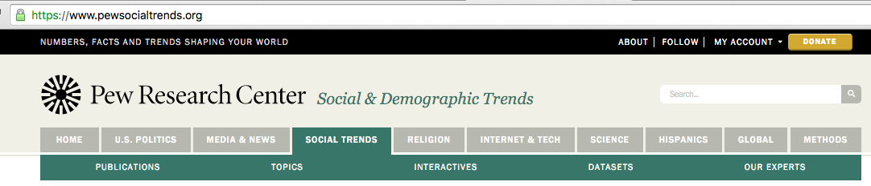

**Use this link below or Google “Pew Research Center” and “Social and Demographic Trends”**

[**https://www.pewsocialtrends.org/**](https://www.pewsocialtrends.org/)

1. **Provide the citation for the article you selected.**

**Below is an example of how to cite the article.**

**Note: The first author’s last name is first, then the last name. All of the additional names are first and last name. The year and a period is next. Place quotation marks around the title. Add the name of the site you retrieved the article from. Add the link with the words, Retrieved from (and make sure the link turns blue so that it is a working link).**Lam, Onyi, Brian Broderick, Stefan Wojcik and Adams Hughes. 2018. “Gender and Jobs in Online Image Searches.” Pew Research Center: Social and Demographic Trends. Retrieved from [**https://www.pewsocialtrends.org/2018/12/17/gender-and-jobs-in-online-image-searches/**](https://www.pewsocialtrends.org/2018/12/17/gender-and-jobs-in-online-image-searches/)**.**

1. **Describe the main idea (thesis) of the article you selected. Explain why you chose this article (e.g., Why is this article important?). Minimum two paragraphs.**
2. **Based on the subject discussed in your article, explain what recommendations you would make related to this subject and explain how your recommendations should have an impact (effect) on society. Minimum one paragraph.**
3. **List ten key (e.g., important or significant) terms that you believe were important in the article you selected.** You are not required to provide the definition. The words you select should be words that you believe are important if an individual read the article and had very little knowledge about the subject. Number the terms 1-10.
4. **Prior to the global pandemic, food insecurity was a major issue nationwide, particularly for many college students. During the Summer 2020/21, some of the John Jay College APPLE Corps students enrolled in the professor’s experiential, *Police and Community*, course participated in a virtual community internship project. As part of their assignment and responsibilities, students were trained and updated the *NYC Neighborhood Food Resource Guide*. (Click on the Link below or Google the name).**
5. **Go to the Guide. This is the link** [**https://www.nycfoodpolicy.org/coronavirus-nyc-food-reports/**](https://www.nycfoodpolicy.org/coronavirus-nyc-food-reports/) **or Google Coronavirus NYC Neighborhood Food Resource Guide.**

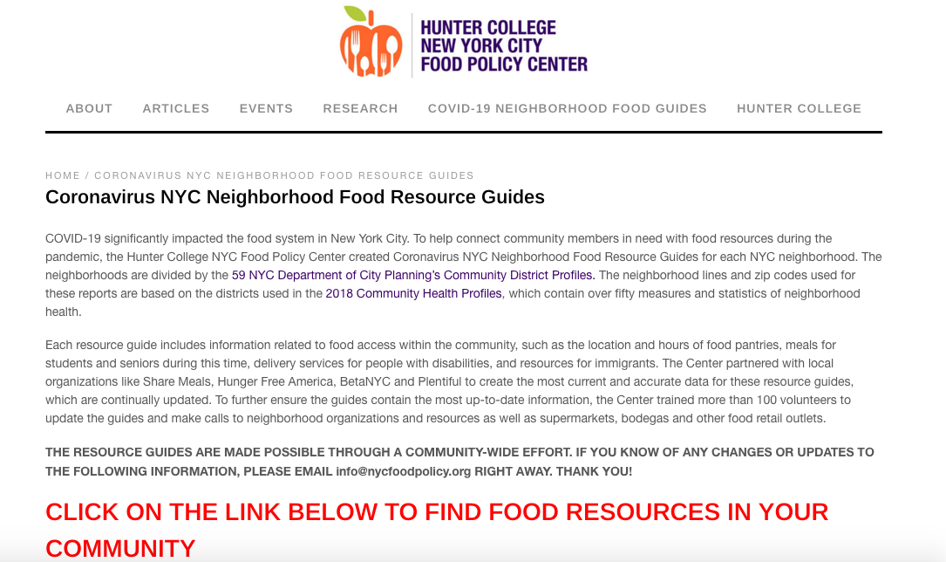

1. **If you live in New York City, locate your NYC Zip Code (Control + F) or If you do not live in NYC, use 10019, the zip code for John Jay College.**
2. **Review the information provided (e.g., neighborhood organizations and resources, including supermarkets, bodegas and other food retail outlets) and answer the questions below. Below is an example, if you selected 10019.**



**Question #1: How can the information contained in the Guide best assist residents in the neighborhood you chose to review? Make sure to include the zip code you are using in your answer? Resource: Google the zip code and zipdatamaps.com for Zip Code Profile Data. How does the profile relate to food insecurity?**

**Question #2: What additional recommendations would you make to help food insecurity in the United States**?  
  
Selected Reading: Question #8: Stebleton, Michael J. and Kaler, Lisa S. [July 7] 2020. Exacerbated Inequities: Food Insecurity, COVID-19, and Higher Education. *The Gender Policy Report.* University of Minnesota. Retrieved from <https://genderpolicyreport.umn.edu/exacerbated-inequities-food-insecurity-covid-19-and-higher-education/>

Selected Reading: Question #: 8. Hunter College Food Policy Center. 2020. *Coronavirus NYC Neighborhood Food Resource Guides*. Hunter College Food Policy Center. Retrieved from <https://www.nycfoodpolicy.org/coronavirus-nyc-food-reports/>

1. **Do you think following ALL of the instructions and followed the checklist on page one? How did this assignment relate to the discipline of sociology? Minimum, one paragraph.**