

**QUOTATION**

**TO Date: 22/02/2024**

**EMT ELECTROMECHANICAL WORKS LLC**

**PROJECT: P0068 FARM GARDEN VILLAS –VALLEY VILLA**

**SUBJECT: QUOTATION FOR PLUMBING WORKS.**

**Dear Sir,**

We are very pleased to submit our best & lowest rate quotation for above mentioned Subject work. The details are as

|  |  |  |  |
| --- | --- | --- | --- |
| **SR.NO** | **Description** | **Qty** | **Rate** |
| **01** | **FRASH AIR RISER AND MAIN LINE** | **PER VILLA** | **625.00** |

* Tools, Transport &Labor will be provided by us.
* Supply and shifting of all using material, Electricity and Scaffolding will be provided by client.

**Payment Terms:**

* Payment will be release within 15 days after submission of invoice.
* VAT amount will be applicable additional to the above mentioned rates.

We hope that you will consider our Quotation and give your favorable reply.

Thanks & regards.

**Yours Truly,**

**BWABAT AL FEIHA TECHNICAL SERVICES LLC.**

**Mr. USMAN KHAN**

**055-7408281**

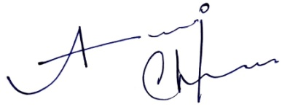**Email: alyaskhan101@gmail.com**