



**INTRODUCTION**

**International banking services are financial activities conducted outside of a bank's home country. For example, a bank offering international banking services may provide service to customers located in other countries, offer letters of credit, or provide investment advice regarding foreign markets.**

**International banking involves banks dealing with money and credit across national borders. It includes offshore banking centres, which allow foreign accounts and are free from the banking regulations of that country.**

**DEFINITION**

**International Banking is a process that involves banks dealing with money and credit between different countries across the political boundaries. It is also known as Foreign/Offshore Banking. In another words, International Banking involves banking activities that cross national frontiers. It concerns the international movement of money and offering of financial services through off shore branching, correspondents banking, representative offices, branches and agencies, limited branches, subsidiary banking, acquisitions and mergers with other foreign banks. All the basic tools and concepts of domestic bank management are relevant to international banking**

**. However, special problems or constraints arise in international banking not normally experience when operating at home**

**In particular:**

**Business activities have to be transacted in foreign languages and under foreign laws and regulations.**

**Information on foreign countries needed by a particular bank wishing to operate internally may be difficult to obtain.**

**Control and communication systems are normally more complex for foreign than for domestic operations.**

**Risk level may be higher in foreign markets.**

**Foreign currency transaction is necessary.**

**International bank managers require a broader range of management skills than managers who are concerned only with domestic problems.**

**It is more difficult to observe and monitor trends and activities in foreign countries.**

**Larger amounts of important work might have to be left to intermediaries, consultants and advisers.**

**International banking deals with all banking transactions-private and governmental- of two or more countries. Private Banks undertake such transactions for profit; governments may be for provision of various services.**

**THE GROWTH OF INTERNATIONAL BANKING**

**The growth of international banking is the increase in cross-border financial services, such as lending, deposits, and investment products. It's measured by the share of international bank lending in the global GDP. International banking grew rapidly in the decades leading up to the financial crisis.**

**The growth was interrupted by the financial crisis, but it remained near peak levels.**

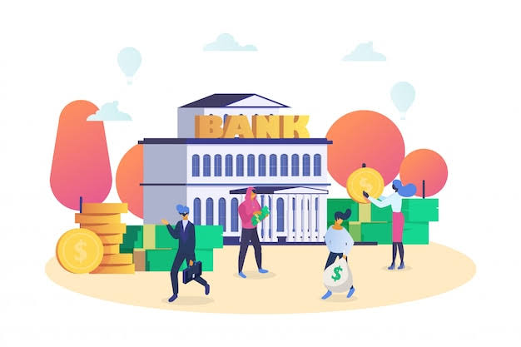

**The growth of international banking has been driven by several key factors, including:**

* **Globalisation of Trade and Investment – As businesses expand across borders, they require international banking services to facilitate trade, manage foreign exchange, and finance overseas operations.**
* **Financial Liberalisation – Many countries have relaxed restrictions on foreign banks, allowing them to establish branches and subsidiaries, leading to increased cross-border banking activities.**
* **Technological Advancements – Digital banking, online transactions, and financial technology have made it easier for banks to offer services internationally and for customers to access banking services from anywhere.**
* **Multinational Corporations (MNCs) – Large corporations operating in multiple countries require global banking solutions, such as international loans, risk management, and cash flow optimisation.**
* **Foreign Exchange Markets – The demand for foreign exchange transactions has increased with growing international trade and investment, requiring banks to provide forex and hedging services.**
* **Deregulation and Policy Changes – Many governments have removed barriers to foreign banking operations, allowing international banks to operate more freely and increasing competition.**
* **Emergence of Offshore Banking – Offshore financial centres offer tax advantages, secrecy, and regulatory benefits, attracting businesses and wealthy individuals to use international banking.**

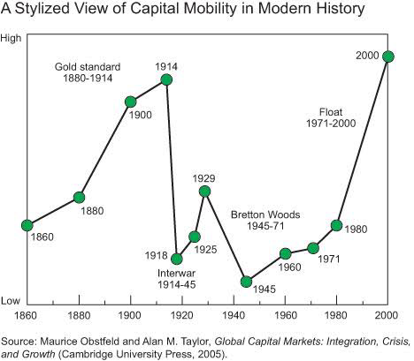

**International banking has grown rapidly since the 1950s due to financial innovation, deregulation, and the rise of multinational corporations.**

**Factors contributing to growth**

* **Financial innovation   
  New financial products like derivatives and syndicated loans have helped banks manage risk.**
* **Financial liberalisation   
  Relaxed regulations have expanded investment opportunities and made it cheaper for banks to borrow and lend abroad.**
* **Multinational corporations   
  The rise of multinational corporations and international trade has increased demand for international banking.**

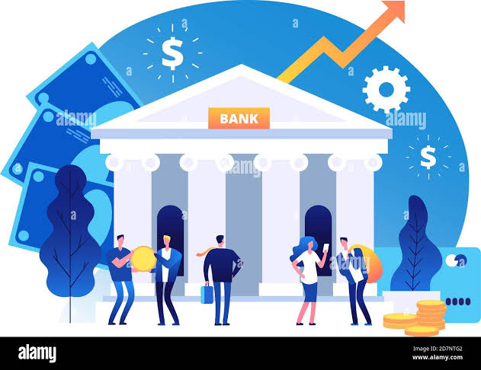

* **International banking helps create a country's currency base in another country.**
* **It makes international trading easier and contributes to trade globalisation.**

**DEFINITION**

**New technology and innovations are getting improved in international payment process by creating more efficiency and transparency. Banking system who are involved in cross border trade should adopt innovative technology to meet customers' expectations.**

**Recent trends in international banking include the use of AI and machine learning, digitalisation, and increased focus on sustainability.**

**The banking sector worldwide, with its years of digital revolution, has experienced some important transformations. Along with the reduction in foot traffic in branches, digital transformation in banking has also experienced diminishing use of cash amidst the rise of digital payment methods.**

**AI and machine learning**

* **Used to analyze potential disruptions, identify data patterns, and access credit risk.**
* **Helps to mitigate potential losses by proactively detecting anomalies in data.**

**Digitalisation**

* **Digitisation of trade documents, such as bills of lading and letters of credit, is becoming more popular .**
* **Digitalisation of customer onboarding and real-time regulatory checks are gaining prominence.**

**Sustainability**

* **Sustainability and decarbonisation are areas of focus to meet the needs of investors and customers .**
* **Banks are increasingly focusing on environment, social, and governance (ESG) compliance .**

**Other trends**

* **Banks are increasingly relying on data to define customer journeys and drive decisions.**
* **Banks are looking to transform their back- and middle-office cost structures.**
* **Banks are collaborating with fintechs to speed up innovation and shorten “time to market” .**
* **Banks are increasingly adopting blockchain .**
* **Banks are increasingly using RegTech to navigate more complex regulatory and compliance landscapes .**

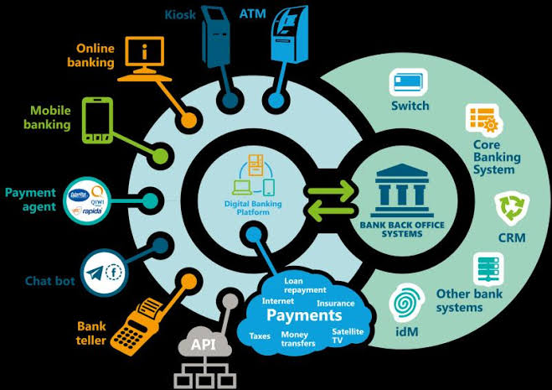

**International banking is evolving rapidly due to technological advancements, regulatory changes, and shifting economic conditions. Here are some key recent trends:**

**1.Digital transformation and fintech integration –**

**Banks are investing heavily in AI, blockchain, and cloud computing to improve efficiency and security.**

**Neobanks and digital-only banks are gaining traction, offering faster and more user-friendly services.**

**Central Bank Digital Currencies (CBDCs) are being explored by major economies (e.g., China’s digital yuan, the EU’s digital euro).**

**2. Cross-Border Payment Innovations**

**SWIFT’s ISO 20022 standard is being adopted to enhance transaction speed and transparency. Blockchain-based payment systems (e.g., Ripple, JPM Coin) are reducing reliance on traditional banking infrastructure.**

**Instant international payment solutions like Visa B2B Connect and Mastercard Cross-Border Services are growing.**

**3. Sustainability & Green Banking-**

**Banks are incorporating ESG (Environmental, Social, and Governance) principles into investment and lending decisions.**

**Green bonds and sustainable financing are expanding, especially in Europe and Asia.**

**Regulators are pushing for climate risk disclosure in banking operations**

**.**

**4. Regulatory Changes and compliance challenges-**

**Stricter AML (Anti-Money Laundering) and KYC (Know Your Customer) regulations are being enforced globally.Basel IV regulations are reshaping capital requirements for international banks.**

**Geopolitical risks (e.g., Russia sanctions, US-China tensions) are increasing compliance burdens.**

**5. De-Dollarisation & Currency Diversification-**

**Countries are exploring alternatives to the US dollar for trade and reserves, increasing the use of Chinese yuan, euro, and local currencies.**

**BRICS nations are pushing for non-dollar trade settlements to reduce reliance on Western financial systems.**

**6. Cybersecurity & Fraud Prevention-**

**Rising cyber threats have led to increased investment in AI-driven fraud detection and biometric security.**

**Banks are focusing on zero-trust security models to protect customer data and transactions.**

**7. Expansion of Islamic Banking-**

**Islamic finance is growing in the Middle East, Southeast Asia, and Africa, with more banks offering Sharia-compliant financial products.**

**Sukuk (Islamic bonds) are gaining popularity in global financial markets.**

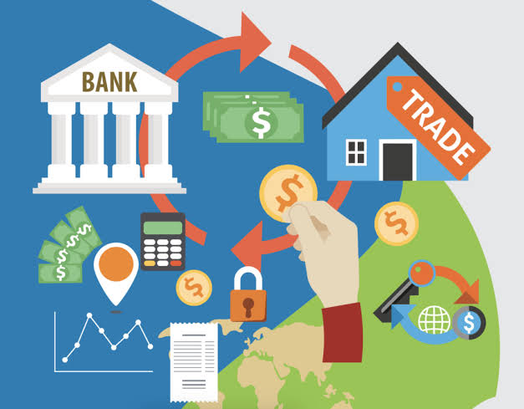

**The banking industry is undergoing a significant transformation driven by advancements in technology. Digitalisation, automation, and data-driven insights have become key focus areas for banks looking to enhance customer experiences , streamline operations, and gain a competitive edge.**

**Hyper automation combines robotic process automation (RPA) with AI and ML capabilities to automate complex business processes end-to-end. Banks can leverage hyper-automation to automate repetitive and rule-based tasks, such as data entry, document processing, and customer onboarding. By automating these processes, banks can reduce errors, improve operational efficiency, and free up employees to focus on higher-value activities.**

**Low-code Development platform like Kiss flow enable banks to build applications with minimal coding requirements, accelerating development and reducing reliance on traditional coding methods.**

**These platforms provide visual interfaces, pre-built templates, and drag-and-drop functionalities, allowing both technical and non-technical stakeholders to participate in application development. Banks can leverage low-code development to quickly create custom applications, streamline internal processes, and deliver innovative customer experiences.**

**Robotic Process Automation (RPA):**

**RPA has gained traction in the banking industry, automating repetitive manual tasks and improving operational efficiency. By deploying software robots, banks can streamline processes such as customer onboarding, data entry, and compliance checks, reducing errors and enhancing productivity.**

**Cloud Computing:**

**Banks are embracing cloud computing to optimise infrastructure costs, improve scalability, and enable faster deployment of applications. Cloud-based solutions offer enhanced data security measures, agility, and the ability to integrate with other systems, enabling banks to innovate and launch new services quickly.**

**Blockchain Technology:**

**Blockchain has emerged as a disruptive force in the banking industry, transforming areas such as cross-border payments, trade finance, and identity verification. Its decentralised and secure nature has the potential to streamline processes, reduce costs, and increase transparency in transactions**

**Biometric Authentication:**

**Biometric authentication technologies, such as fingerprint recognition, facial recognition, and voice recognition, are gaining popularity in the banking industry.**

**These technologies provide enhanced security and convenience by using unique biological characteristics for user identification and authentication. Biometric authentication can be used for secure access to banking applications, transaction verification, and identity verification during customer onboarding processes.**

**RegTech:**

**RegTech, short for regulatory technology, refers to the use of technology to streamline regulatory compliance processes in the banking industry. Banks face numerous regulatory requirements, and RegTech solutions help automate compliance monitoring, reporting, and risk management.**

**These technologies utilise AI, machine learning, and data analytics to ensure adherence to regulations, reduce compliance costs, and minimise the risk of regulatory violations.**

**Open Banking:**

**Open banking initiatives aim to increase competition and innovation in the banking industry by allowing customers to securely share their financial data with authorised third-party providers.**

**Through open APIs (Application Programming Interfaces), banks can collaborate with fintech companies and other financial institutions to develop new products and services that meet customer needs.**

**Open banking promotes data sharing, enables personalised financial solutions, and enhances the overall customer experience.**

**Payment Processing:**

**With the rise of digital payments and customers' evolving needs, payment processing technologies are rapidly advancing.**

**Banks are adopting faster and more secure payment methods like contactless payments, mobile wallets, and real-time payment systems.**

**These technologies offer convenience, speed, and improved transaction security, enabling customers to make payments seamlessly across various channels and devices.**

**Digital payment processing in international banking involves a payment gateway collecting payment information and transferring it to a payment processor. The processor then transfers funds between the customer's bank account and the merchant's account.**

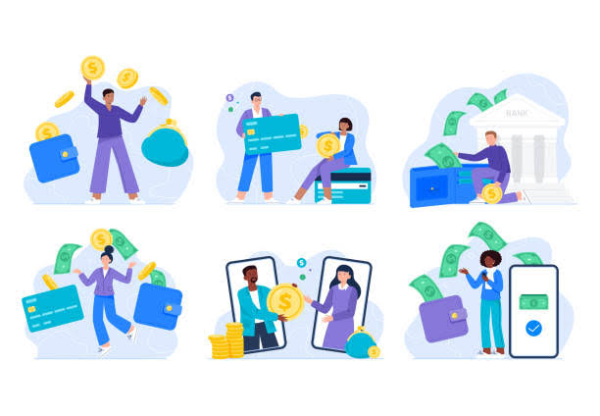**CONCLUSION :**

**International banking has changed in recent years due to technological advancements, regulatory shifts, and the global financial crisis.**

**The future of international banking will require banks to embrace innovation, enhance customer experiences, and adopt agile strategic planning. Banks that can effectively manage risks and respond to customer needs in real-time will thrive.**