English Formal 1
Listening and Speaking
Reading
Question | Answer | Mark | Blooms level
Listening and Speaking:  Pretend that you are in the race and draw a picture about the story “The tortoise and the hare.” | Listens to the story without interrupting. /1  Draws a picture that is relevant to the story. /2  The picture is neat and detailed. /1,5  1 – the learner listens to the story without interrupting  0 – learner does not listen  2 – learner draws a picture of themselves in the picture with the tortoise and the hare that is relevant  1 – learner draws a picture, you can see the tortoise, hare and the learner  0 – the learner has drawn an irrelevant picture that makes no sense.  1,5 - the picture is detailed and neat  1 – the picture is neat  0 – the picture makes no sense | 4,5 | Level 3
- Identify the two main animals in the story? | The tortoise  The hare  0,5 for each animal | 1 | Level 1
- Describe how you would feel if you were the tortoise and were being teased? | Mark may be given if learner writes anything to do with being sad, upset, angry etc. | 1 | Level 1
Listening and Speaking:  - Where does the race take place? Summarise it below | The race takes place in the forest | 1 | Level 2
- Can you tell me how the tortoise is different to the hare? | The tortoise is slow / the hare is fast  The tortoise didn’t show off and won/ the hare was showing off and lost  The tortoise has a shell/ the hare has fur | 1,5 | Level 2
Reading:  - In your opinion, what is the moral of the story? | Never give up/always try | 1 | Level 4
- What did you think when the tortoise won? | Own opinion | 1 | Level 5
Reading:  Look at the pictures and tell the story | 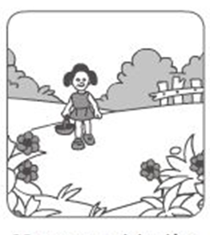  -There is a little girl walking in the garden with a basket looking at flowers.  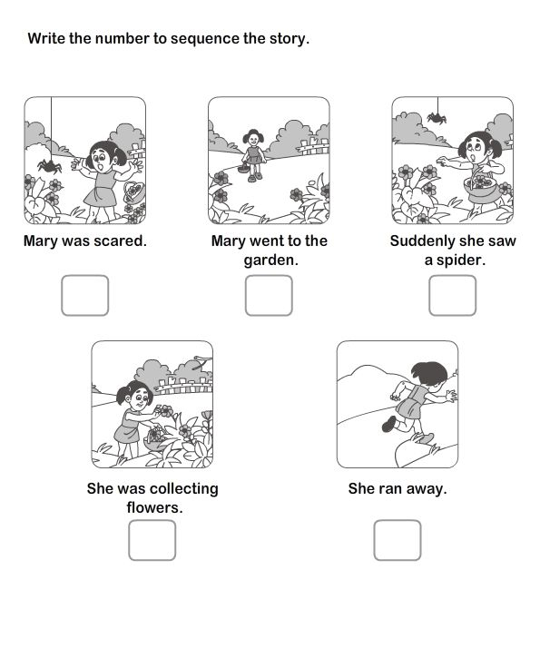  -The girl is picking some flowers in the garden.  -The girl is picking 3 flowers in the garden.  -The girl sees a spider and looks very scared/she gets a fright.  -The spider jumps down onto the flowers and the girl drops her flowers/basket.  The girl leaves her flowers/basket and runs away. | /10  2 marks per sentence:  1 mark - to relevance.  1 mark – to a full sentence. | N/A
Reading:  Number the pictures and show the correct sequence. | 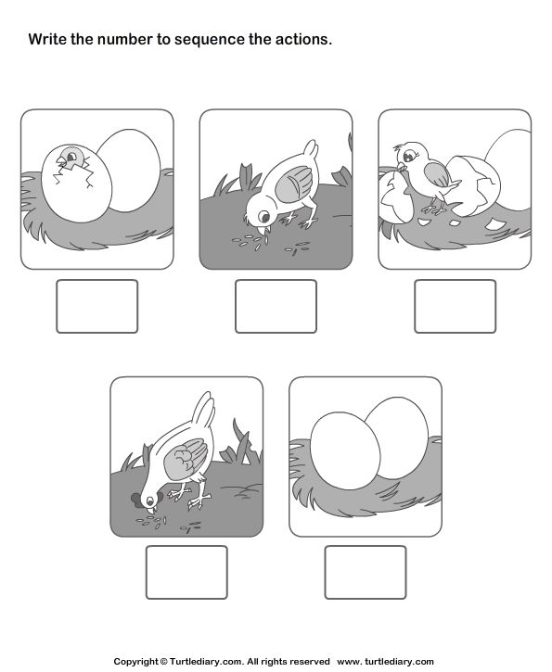  3  1  2  4 | 4 | N/A

