**SALES AND PURCHASE AGREEMENT**

EXPIRED, RECYCLABLE AND USED GOLD (AU)

INTERNATIONAL PRECIOUS METAL HS71081200 (IN BAR FORM)

**DRAFT ONLY FINAL APPROVAL BY RELEASING SELLER ‘S TRANSACTION CODE**

Seller Transaction Code:

Buyer Transaction Code:

Date: 26 July 2022

This Sales and Purchase Agreement (hereinafter referred to as “**SPA**”) is made and effective this 25th day of June 2022,

By and between

Seller : BFA (THAILAND) COMPANY LIMITED

Represented by : PHANID PHOOKAEW

Address : 95/19, Soi Wat Weluwanaram 5, Don Mueang Subdistrict, Don Mueang District. Bangkok, 10210 Thailand

Company registration number : 0105558135785

Passport number : AC3588712

(Hereinafter referred to as “**Authorized Signatory / Seller**”)

And

Buyer :

Represented by :

Address :

Passport number :

(Hereinafter referred to as “**Authorized Signatory / Buyer**”)

All parties may be referred to individually as a “party”, or collectively as “parties”.

**Subject**: expired, recyclable and used international precious metal HS71081200, **GOLD (Au) in bar form** - importable and exportable worldwide; of between 99.95% and 99.99% purity / fineness, governed by privately-owned company/ies; and legitimate for international import or export as return goods / exchange / backup currency / commercial purposes.

**RECITALS**

**WHEREAS,** the Seller has the authority and legal right to sell this Expired/Recyclable/Used precious GOLD (Au) Metal as specified herein (hereinafter referred to as “**Commodity**”) on behalf of the Owner, under private and off-market terms and conditions, and enters into this SPA under the Transaction Code: **_________________________________________________**.

**WHEREAS,** the Seller complies with one of the following LBMA industry initiatives; Responsible Gold Guidance based on Recycled Gold: Gold that has been previously refined. This term traditionally encompasses anything that is gold-bearing and has not come directly from a mine in its first gold life cycle. In practical terms, recyclable material includes end-user, post-consumer products, scrap and waste metals, and materials arising during refining and product manufacturing, and investment gold and gold-bearing products. This category may also include fully refined gold that has been fabricated into grain, good delivery bars, medallions and coins that have previously been sold by a refinery to a manufacturer, bank or consumer market, and that may thereafter need to be returned to a refinery to reclaim their financial value, or for transformation into other products (e.g. 1 Kilo bars).

**WHEREAS,** the Seller presents to the Buyer a verifiable Notary Certificate confirming that the Seller has at the Seller's disposal a Contract from the **Commodity** owner allowing the Seller to sell and transfer the legal and beneficial title, pertaining to the quantity of the **Commodity** as stated herein (which will be confirmed via a bank-to-bank basis).

**WHEREAS,** the Seller confirms and warrants that the **Commodity** is free and clear of any liens, encumbrances, or mortgages. The Seller further confirms and warrants that the **Commodity** is not subject to any legal action, nor is it of criminal origin, nor has it been left as a deposit or collateral for a credit line or a financial instrument and are fully trad-able and movable out of **DUBAI SECURITY / BONDED WAREHOUSE.** The Seller will provide to the Buyer with Export Permit / Export License for the GOLD which can be verified before the Buyer pays for the GOLD (subject to the final assay report and transfer of the titles of the Commodity).

**WHEREAS,** the Buyer, confirms with full corporate authority and legal responsibility, that the Buyer is ready, willing and able to purchase the said Commodity using US dollar (“USD”) funds, which are good, clean, clear; authenticated as genuine, unencumbered and non-criminal origin.

**WHEREAS**, the Seller does not accept a bank instrument via SWIFT to the Seller, by a third-party in which the Buyer is not the applicant or the title owner of the said bank instrument; and/or such bank instrument is the so-called lease or rental bank instrument. No third-party financing, leasing, rental from a third-party instrument provider is accepted. The Buyer and any the contracting party must have their own line of credit with the bank and not use third party money.

**WHEREAS,** both Parties mutually accept to refer to the General Terms and Definitions, as set out by the INCOTERMS Edition 2000 with latest amendments.

**NOW, THEREFORE,** in consideration of the mutual interests and covenants, both Parties hereby confirm with full corporate and legal responsibility, under penalty of perjury, and unconditionally agree to the following terms and conditions stipulated hereunder.

**REPRESENTATION & WARRANTY**

I, BFA (THAILAND) COMPANY LIMITED. Miss Phanid Phookaew. Holding Thailand Passport No.: AC3588712 acting as the Seller, declare that the Seller hereby confirms with corporate responsibility, in accordance with the Description of Objectives No. 35 registered as a juristic person under the Civil and Commercial Code of Thailand:

**Description of Objectives No. 35 (Trading License)**

***"Execution of international trade, import, export of expired, recyclable and used international precious metals, land and air transport, import and export by third party logistics".***

that on behalf of the Owner of the Commodity, the Seller is ready, willing and able to enter into the contract for selling GOLD (Au) bars of between 99.95% and 99.99% purity / fineness to the Buyer.

______________________________ acting as the Buyer, with corporate responsibility, attest that the Buyer has the ample and verifiable financial capability and has obtained all necessary legal documentation to enable the rights to purchase the said **Commodity** in the amount of 4,800 kg. (Four thousand eight hundred kilogram) for the first (1st) tranche and with Rolls and Extensions thereafter.

**SPECIFICATIONS**

1. Commodity: International Precious Metal HS71081200 in Bar Form

Importable and Exportable Worldwide Original GOLD (Au) registered Bars in 1 Kg and 12.5 Kg weight (GOLD expired) Customs Tariff Numbers / Harmonized System Codes: 7108, 71081200, 71081300

2) Specifications: Purity / fineness of between 99.95% and 99.99%

Note: Kg to Oz conversion: 32.1507466 (Fine Troy Ounce) to compute the Discount based on LBMA Pricing Index

3) Quantity & Terms: 40 MT contract with rolls and extensions per year, with partial shipment allowed, but not below 400 kg per shipment.

4) Shipments: The First Tranche will be 4,800 kilogram and subsequent lifts will be on schedule agreed by both Parties as per Appendix I

Note: The payment guarantee must cover 4,800 kilogram for the first shipment in order to obtain this price range. All bank-to-bank SWIFTs (No ATV) must be fully RMA established, authenticated and confirmed through the SWIFT headquarters in Brussels, Belgium and the internal department of the ISSUING AND RECEIVING bank. Any intervention with SWIFT, offline SWIFT, dummy SWIFT, off-ledger funds, SWIFT misrepresentation or counterfeiting of SWIFT will be reported and a penalty of 1% will be compensated to the Seller.

5) Examples of Hallmarks available:

EXPIRED, RECYCLABLE AND USED goods, more than 5 years old, to be renovated/smelted into international accepted goods of purity of 99.95% to 99.99%, with gold certificate from mutually agreed Buyer designated refinery with well-known proper accreditation. For the sake of calcification, all International Precious Metal HS71081200 in Bars, whether it is less than 5 years old or more than 5 years old, must first be returned to a mutually agreed Buyer designated refinery with well-known proper accreditation to avoid counterfeiting and for the process of refining or scanning, recycling, redemption, certificate renewal and financial recovery before these International Precious Metal HS71081200 in Bars can be sold commercially.

BRAND SIZE ORIGIN

* 1. Umicore +-12.5 KG/24K/40mm Belgium
  2. Royal Mint +-1 KG/24K/9.2mm England
  3. Baird & Co. +-1 KG/24K/9.2mm England
  4. Perth Mint +-1 KG/24K/9.2mm Australia
  5. PAMP SA +-12.5KG/24K/40mm Switzerland
  6. Metalor +-12.5 KG/24K/40mm Switzerland
  7. Valcambi +-12.5 KG/24K/40mm Switzerland
  8. Commerzbank +-1 KG/24K/9.2mm Switzerland
  9. Heraeus +-1 KG/24K/9.2mm Germany
  10. Argor-Heraeus +-1 KG/24K/9.2mm Switzerland
  11. RAND Refinery +-1 KG/24K/9.2mm South Africa
  12. Nippon Mining +-1 KG/24K/9.2mm Japan
  13. Mitsubishi +-1 KG/24K/9.2mm Japan
  14. Johnson Matthey +-1 & 12.5 KG/24K Hong Kong
  15. Emirates +-1 KG/24K/9.2mm UAE
  16. Degussa +-1 KG/24K/9.2mm Germany
  17. Logam Mulia +-1 KG/24K/9.2mm Indonesia
  18. LS Nikko +-1 & 12.5 KG/24K South Korea
  19. Nadir Metals +-1 & 12.5 KG/24K Turkey
  20. UBS +-1 KG/24K/9.2mm Switzerland
  21. Credit Suisse +-1 KG/24K/9.2mm Switzerland
  22. Etihad +-1 KG/24K/9.2mm UAE

**PRICE: DISCOUNT & COMMISSIONS**

1) Selling Price: (valid for 15 BANKING days from the date of issue and / or the signatures of both Parties of this document; please do not sign this contract if the Buyer does not intend to meet the deadline):

Subject to the fact that the Buyer is to issue the payment guarantee of the DLC via SWIFT MT700 OR MT799 BLOCKED-FUNDS (Authenticated with Bank Compliance - Qualified RMA), for the minimum quantity of 400 kilogram, then:

The Discount is GROSS, LBMA -12% / NET -9% to Buyer DDP or CIF at the Buyer's gold refinery, PER 1Kilogram based on Second Price Fixing at the LBMA on the prior day of execution for Good Delivery Bars with a minimum grade of 99.95% purity of Au. In the event LBMA is not operating on that scheduled day, the price calculation shall be used based on the 2nd LBMA fixing of the Market opening day; inclusive of Malca-Amit or Brink’s Security Insurance.

2) Consultancy Fee: Total Commission is 3 % per kilogram - paid by Seller

7.1) 1.5% to Seller’s Representatives: Closed

7.2) 1.5% to Buyer’s Representatives: Open

**PAYMENT**

1) Payment:

***Note****: All SWIFT must be RMA (Relationship Management Application) activated, qualified and established through SWIFT MT999 by Buyer's and Seller's Banking Compliance Decision prior to sending SWIFT or Payment Guarantee.*

The Buyer's bank will send the Seller's bank a SWIFT MT199 RWA with RMA activated and advise readiness to issue a PAYMENT GUARANTEE of NON-OPERATIONAL, Irrevocable, Confirmed, Revolving, Non-Transferable and Non-assignable DLC via SWIFT MT700 OR MT799 BLOCKED-FUNDS (Authenticated with Bank Compliance Qualified RMA) authenticated with RMA activated and confirmed via SWIFT's head office in Brussels, Belgium, at the face value of the purchased amount of minimum 400 kilogram of gold "expired, recyclable and used”.

The Seller's bank responds with Proof of Product (POP) via SWIFT MT600/699 within 3 banking days to confirm the product for a minimum quantity of 400 kilogram of “expired, recyclable and used” gold that is available and lift-able.

Upon receipt of the POP via SWIFT MT600/699 from the Seller's bank, the Buyer’s Bank sends an authenticated NON-OPERATIVE DLC via SWIFT MT700 OR MT799 BLOCKED-FUNDS (Authenticated with Bank Compliance Qualified RMA) with RMA activated and confirmed via SWIFT's head office in Brussels, Belgium (Appendix - e) at the nominal value of the lifting amount or 400 kilogram of “expired, recyclable and used” gold to trigger and activate the seller's 2% Performance Bond. Upon activation, a hard copy POP document to be sent via DHL International Shipping to the Buyer's bank comprising;

1. Deposit Confirmation Letter (DCL) with proof of ownership
2. Logistical Reports
3. Insurance Certificate Number

(With the invitation to the inspection of the gold bars, issued by the Depository, based on the Deposit Confirmation Letter, to inspect the first lift of 400 kilogram. Alternatively, this invitation can be sent directly from the Depository to the Buyer).

***Note****: Optional – Weekly Lift Amount other than the minimum 400 kilogram.*

As a payment guarantee, the Buyer will issue an authenticated, RMA enabled, cash-backed, irrevocable, non-assignable, non-operational, non-transferable and non-assignable DLC via SWIFT MT700 OR MT799 BLOCKED-FUNDS (authenticated with Bank Compliance Qualified RMA) (APPENDIX - E) (Authenticate and Confirm via SWIFT Headquarters in Brussels, Belgium) to trigger the seller's MT600/699 and a 2% Performance Bond from the Seller with the face value of the weekly lift amount, prior to the seller releasing the product for delivery to refinery for a new, final assay.

Based on the daily smelting capacity of Refinery per day (Saturday, Sunday and Public holidays not included), Seller shall issue invoice to Buyer based on the daily Preliminary Assay Report. Buyer shall arrange payment within 5 banking days after the Final Assay Report being issued.

Payment is made to the Seller via SWIFT MT 103 within five (5) banking days of the issuance of the final refinery assay report. Transfer of ownership from Seller to Buyer after receipt and acceptance of SWIFT MT103 by Buyer's bank.

**TITLE**

1) Ownership:

Transfer of ownership from Seller to Buyer after receipt and acceptance of SWIFT MT103 by Buyer’s bank in according with Clause 8 above.

**DELIVERY**

1) Delivery: DDP or CIF Buyer's gold refinery

**DOCUMENTATION**

1) Documents:

The Seller shall authenticate, declare, legalize, register, provide and guarantee documents from relevant government sectors; and Seller’s responsibility of each tranche/lift shall be accompanied by the following:

* Certificate of Assay Report
* Certificate of Ownership
* AIR WAYBILL
* Commercial Invoice
* Tax certificates
* Import-Export license
* Certificate of Origin
* Warehouse receipt and list of products
* Customs Clearance Certificate

***Note: If the Buyer needs the Seller to issue the invoice with specific details such as: Chamber of Commerce licensed XXX, or company XXX, which is necessary to clear the gold bars from the XXX Customs on behalf of XXX – XXX, Passport number, etc.; the Seller will issue such invoice with details as follows:***

***INVOICE TO: XXX***

***DELIVERY TO: TBA***

**BANKING COORDINATES**

1) BANKING DETAILS (SELLER’S BANK):

**(**AUTHENTICATE AND CONFIRM VIA THE SWIFT HEADQUARTERS IN BRUSSELS, BELGIUM): All SWIFT must be RMA activated, qualified and established through SWIFT MT999 by Buyer's and Seller's Banking Compliance Decision prior to sending SWIFT or Payment Guarantee.

|  |  |
| --- | --- |
| **BANK NAME** | BANGKOK BANK PUBLIC COMPANY LIMTED |
| **BANK ADDRESS** | Inthamara Branch, Viriyathavorn Building, Suthisarn Road, Dindeang, Bangkok 10400, Thailand |
| **ACCOUNT NAME** | **BFA (THAILAND) COMPANY LIMITED** |
| **ACCOUNT NUMBER** | **138-459727-2** |
| **NAME OF SIGNATORY** | PHANID PHOOKAEW |
| **THAI PASSPORT NO.** | AC3588712 |
| **SWIFT CODE** | BKKBTHBK |
| **BANK OFFICER** | Mr. Weerapong Kanjanumpom (Any direct contact of the buyer or any third party, except the authorized OFFICER of the buyer's bank, with our bank is strictly prohibited and will result in the immediate termination of this SPA). RMA is required for SWIFT authorization and qualification before sending payment guarantee |
| **BANK TEL / FAX** | +662 277 2551 / +662 277 0788 OR +662 680 9559 FOR +662 230 1036  INTERNATIONAL / TRADE FINANCE / SWIFT DEPARTMENT –BANGKOK BANK HEAD OFFICE (SILOM) |
| **BANK EMAIL** | weerapong.kan@bbl.co.th; BSOBCHeadOffice@bbl.co.th; bbltradeadvisor.tfc@bbl.co.th |

2) BANKING DETAILS (BUYER’S BANK):

**TO PAY BY TT REMITTANCE TO THE SELLER AND SEND A PAYMENT GUARANTEE TO THE SELLER (**DLC via SWIFT MT700 OR MT799 BLOCKED-FUNDS (Authenticated with Bank Compliance Qualified RMA**) (**AUTHENTICATE AND CONFIRM VIA THE SWIFT HEADQUARTERS IN BRUSELS, BELGIUM AND SWIFT.COM): All SWIFT must be RMA activated, qualified and established through SWIFT MT999 by Buyer's and Seller's Banking Compliance Decision prior to sending SWIFT or Payment Guarantee.

|  |  |
| --- | --- |
| BANK NAME |  |
| BANK ADDRESS |  |
| ACCOUNT NAME |  |
| NAME OF SIGNATORY |  |
| ACCOUNT NUMBER |  |
| SWIFT CODE/IBAN |  |
| BANK CODE |  |
| BANK OFFICER |  |
| BANK OFFICER’S EMAIL |  |
| BANK TEL / FAX |  |

3) Buyer's Bank DETAILS; FOR RECEIVING MT600/699 AND PB2% FROM SELLER AND PAYMENT to the seller VIA MT103 AFTER REFINERY REPORT (AUTHENTICATE AND CONFIRM VIA THE SWIFT HEADQUARTERS IN BRUSSELS, BELGIUM AND SWIFT.COM): All SWIFT must be RMA activated, qualified and established through SWIFT MT999 by Buyer's and Seller's Banking Compliance Decision prior to sending SWIFT or Payment Guarantee.

|  |  |
| --- | --- |
| BANK NAME |  |
| BANK ADDRESS |  |
| ACCOUNT NAME |  |
| NAME OF SIGNATORY |  |
| ACCOUNT NUMBER |  |
| SWIFT CODE/IBAN |  |
| BANK CODE |  |
| BANK OFFICER |  |
| BANK OFFICER’S EMAIL |  |
| BANK TEL / FAX |  |

**TRANSACTION PROCEDURES**

1) After having obtained the mutual agreement (due to the Covid-19 pandemic, electronics signature is acceptable), the Buyer and the Seller will sign and seal this Sales and Purchase Agreement (SPA) with their full banking coordinates. Both Parties shall then each lodge one original copy of this Sales and Purchase Agreement (SPA) with their respective banks.

2) The Buyer's bank will send the Seller's bank a SWIFT MT199 RWA with RMA activated and advise readiness to issue a PAYMENT GUARANTEE or NON-OPERATIONAL, Irrevocable, Confirmed, Revolving, Non-Transferable and Non-assignable DLC via SWIFT MT700 OR MT799 BLOCKED-FUNDS (Authenticated with Bank Compliance Qualified RMA) authenticated with RMA activated and confirmed via SWIFT's head office in Brussels, Belgium, at the face value of the purchased amount of minimum 400 kilogram of gold "expired, recyclable and used”.

3) The Seller's bank responds with Proof of Product (POP) via Swift MT600/699 within 3 banking days to confirm the product for a quantity of 400 kilogram of “expired, recyclable and used” gold that is available and lift-able.

4) Upon receipt of the POP via SWIFT MT600/699 from the Seller's bank, the Buyer’s Bank sends an authenticated NON-OPERATIVE DLC via SWIFT MT700 OR MT799 BLOCKED-FUNDS (Authenticated with Bank Compliance Qualified RMA) with RMA activated and confirmed via SWIFT's head office in Brussels, Belgium (APPENDIX-E) at the nominal value of the lifting amount or 400 kilograms of “expired, recyclable and used” gold to trigger and activate the seller's 2% Performance Bond. Upon activation, a hard copy POP document to be sent via DHL International Shipping to the Buyer's bank comprising;

1. Deposit Confirmation Letter (DCL) with proof of ownership
2. Logistical Reports
3. Insurance Certificate Number

(With the invitation to the inspection of the gold bars, issued by the Depository, based on the Deposit Confirmation Letter, to inspect the first lift of 400 kilogram. Alternatively, this invitation can be sent directly from the Depository to the Buyer).

*Optional – Minimum ordered amount of more than 400 kilogram:*

As a payment guarantee, the Buyer will issue an authenticated, RMA enabled, cash-backed, irrevocable, non-assignable, non-operational, non-transferable and non-assignable DLC via SWIFT MT700 OR MT799 BLOCKED-FUNDS (Authenticated with Bank Compliance Qualified RMA) (Authenticate and Confirm via SWIFT Headquarters in Brussels, Belgium) to trigger the Seller's MT600/699 and a 2% Performance Bond from the Seller with the face value of the weekly lift amount, prior to the Seller releasing the product for delivery to refinery for a new, final assay.

5) The Buyer along with an assayer of the Buyer’s choice will then be invited to the Seller’s security warehouse for a physical viewing/inspection of the amount of Precious Metal for the first tranche within 3 banking days.

6) Within 3 banking days of the physical inspection, the Seller will transport the mutually agreed quantity to the refinery designated by the Buyer at the Seller’s expense DDP or CIF Buyer's gold refinery, and the precious metal refining in the refinery of the Buyer will be at the Buyer’s expense.

7) After refinement and the Refinery Final Assay Report issued by the Buyer’s refinery, the Buyer will settle payment in full for an equal amount of precious metals within 5 banking days to the Seller. The transfer of the Precious Metal Holder is made against final payment. Then the title deed of equal amount will be transferred to the Buyer. Payment will be made by MT103 Cash Transfer without any delay within 5 banking days after the issuance of the assay report by the Buyer’s nominated refinery. Transfer of ownership from Seller to Buyer after receipt and acceptance of SWIFT MT103 by Seller's bank.

8) In the event that the Seller shall fail to deliver any mutually agreed quantity to the Buyer’s appointed refinery within 5 banking days of the expected date, the Buyer shall be entitled to terminate this Sales and Purchase Agreement (SPA) or written notice to the Seller, without prejudice to its right to claim pursuant to the 2% Performance Bond or penalty.

**Validity**

1) This Sales and Purchase Agreement (SPA) will remain valid for a period of only fifteen (15) banking days, during which the Buyer shall, upon signing this SPA, issue the SWIFT MT199 RWA with RMA activated and advise readiness to issue a PAYMENT GUARANTEE or an authenticated, RMA enabled, cash-backed, irrevocable, non-assignable, non-operational, non-transferable and non-assignable DLC via SWIFT MT700 OR MT799 BLOCKED-FUNDS (Authenticated with Bank Compliance Qualified RMA) (APPENDIX - E.) (Authenticate and Confirm via SWIFT Headquarters in Brussels, Belgium) to trigger the seller's MT600/699 and a 2% Performance Bond pursuant to Clause 16 above. If the Buyer was unable to perform the said issuance, this Sales and Purchase Agreement (SPA) will expire automatically.

2) In the event that the Buyer actually perform accordingly, then this SPA will remain valid until the last delivery unless being extended to any specific date to be mutually agreed by both Parties.

**GOVERNING LAW AND DISPUTE RESOLUTION**

1) This Sales and Purchase Agreement (SPA) shall be governed by and construed in accordance with the United Kingdom Law, and the language of this Sales and Purchase Agreement (SPA) shall be in English.

2) Any disputes between the Parties (hereinafter referred to as “Disputes”) shall be first amicably discussed and resolved between the Parties within a period of sixty (60) days from the date of written notice of the said Dispute by the respective Party raising the Dispute to the other Party, failing which, unless otherwise extended for amicable settlement of the said Disputes, the Parties agree to submit the portion of the unresolved Disputes for arbitration in the courts of United Kingdom in accordance with the Rules and Regulations of the International Chamber of Commerce (ICC). The number of arbitrators shall be one and the language of the arbitration shall be in English.

3) The Parties further agree that the outcome of the findings of the Arbitration shall be deemed as final and conclusive, and binding upon the Parties as the final settlement of the Disputes under this Sales and Purchase Agreement (SPA).

4) A Party is not liable for failure to perform its obligation if such failure is as a result of acts of God (including fire, flood, earthquake, storm, hurricane or other natural disaster), war, invasion, act of foreign enemies, hostilities (regardless of whether war is declared), civil war, rebellion, revolution, insurrection, military or usurped power or confiscation, terrorist activities, nationalization, government sanction, blockage, embargo, labor dispute, strike, lockout or interruption or failure of electricity or telephone service. No Party is entitled to terminate this Sales and Purchase Agreement (SPA) under such circumstances.

5) Force majeure events related to COVID-19 are not accepted in this SPA for any reason. The Buyer is fully aware of the COVID-19 situation. He / She signs the SPA during the COVID-19 period, and COVID-19 issues may arise during the contract period.

**APPENDIX LIST**

A. Authorized Signatory / Buyer’s Passport

B. AUTHORIZED SIGNATORY / SELLER’S PASSPORT

C. Buyer’s Company Certificate

D. END SELLER’S COMPANY CERTIFICATE & TRADING OBJECTIVE/LICENSE

E. DRAFT DLC VIA SWIFT MT700 swift VERBIAGe

**F. SELLER’S PERFORMANCE BOND GUARANTEE VIA SWIFT MT760 VERBIAGE**

**G. SELLER’S CONFIRMATION OF PRODUCT VERBIAGE VIA SWIFT MT600/699**

h. Verbiage DCL Depository confirmation letter

I. SHIPMENT SCHEDULE

**PREVENTION OF FRAUDULENT ACTIVITIES**

1) In the event that the buyer's bank is not a correspondent bank with the seller's bank; an RAM (Relationship Management Application) via SWIFT MT999 is required for SWIFT qualification and authentication from the buyer's bank before sending a payment guarantee. The Buyer should consult their bank before sending a SWIFT.

2) Verification of SWIFT and bank instruments from Buyer, bank and Seller’s bank (bank-to-bank SWIFT messages):

2.1) After successful confirmation from the receiving bank by bank email to the issuing bank designated in this SPA contract (NO unforeseen SWIFT events from a third party bank outside of this contract are accepted), which SWIFT has never been officially sent, or falsely claims that the SWIFT was sent or sent as UNAUTHENTICATED, COUNTERFEIT, OFFLINE OR DUMMY SWIFT by the buyer, the BUYER will cover the SELLER a penalty of 1% for claiming that the SWIFT was sent. The SWIFT tracking receipt and a letter or email confirming that SWIFT is 100% authenticated and confirmed by SWIFT Headquarters in Brussels, Belgium is required from the buyer – this is non-negotiable.

2.2) Should the RECEIVER claims that his Receiving Bank has not receive the SWIFT as per the SWIFT CUSTOMER COPY provided by the BUYER/SENDER with receiving bank auto reply, the issuing bank officer must send a bank e-mail to the receiving bank officer and to the seller, as well as to the SWIFT head office in Brussels Belgium (below) with the SWIFT CUSTOMER COPY attached and specify that the SWIFT message has been sent. In the event that no evidence from the Receiving Bank Officer that the SWIFT message is not received and NO delivery of the product, SELLER shall consider breach of contract and BUYER shall entitle to claim the (two) 2% Performance Bond or penalty from SELLER.

2.3) The BUYER's SWIFT is subject to 100% CONFIRMATION from SWIFT Headquarters in Brussels, Belgium and the receiving bank with the official SWIFT Tracking Receipt from the issuing bank and the SWIFT, and a Confirmation from SWIFT Headquarters which the buyer has engaged, registered and sent SWIFT is required (BUYERS ARE REQUESTED TO PROVIDE A COPY OF SWIFT (A COPY OF CUSTOMER RECEIPT) TO ALL RECIPIENTS ATTACHED WHEN SENDING TO SELLER and specify that the SWIFT message has been sent):

THIS SECTION IS FOR SELLER USED FOR VERIFICATION OF SWIFT AND OTHER BANKING DOCUMENTS RECEIVED FROM BUYER ONLY;

SELLER'S BANK;

TBA

SELLER'S CORRESPONDING BANK (For witnessing purposes only);

DAVE WATTS

CHIEF FINANCIAL OFFICER AND DIRECTOR, HSBC UK BANK PLC

[DAVE.WATTS@HSBC.COM](mailto:DAVE.WATTS@HSBC.COM)

SWIFT HEAD OFFICE, BRUSSELS, BRUSSELS CAPITAL, BELGIUM (For witnessing purposes only);

STEPHEN GILDERDALE

CHIEF OPERATING OFFICER

BRUSSELS, BRUSSELS CAPITAL, BELGIUM

[STEPHEN.GILDERDALE@SWIFT.COM](mailto:STEPHEN.GILDERDALE@SWIFT.COM)

MR. JAVIER PEREZ-TASSO

CHIEF EXECUTIVE OFFICER

LA HULPE, WALLONIE, BELGIUM

CHIEF EXECUTIVE OFFICER @ SWIFT

[JAVIER.PEREZ-TASSO@SWIFT.COM](mailto:JAVIER.PEREZ-TASSO@SWIFT.COM)

3) In the event of any suspicion of SWIFT such that the format or layout of SWIFT becomes inconsistent and DOES NOT correspond to the standard “SWIFT protocol”, a typo or spelling error on SWIFT may be produced offline or fictitious or DO NOT follow the final SWIFT format on behalf of the issuing bank, the Seller has the right to temporarily suspend the SPA until the seller has fully verified with the issuing bank and the SWIFT Headquarters in Brussels, Belgium.

4) In the event that the SWIFT copy, i.e. the customer copy received from any other third party/ies which/who is/are not the signatory to this SPA, the Seller then becomes receiver and has the right to become a customer of the issuing bank and the SWIFT copy is deemed suspicious in terms of format or layout or if the Seller deems it not to be the standard SWIFT protocol, the Seller has the right to invite and incorporate one independent party or one of the top 25 banks to be its witnesses and assist it in the SWIFT verification of the buyer within the framework of a correspondence or a partnership agreement with the seller's bank.

5) In the event of the instrument issued is found to be fictitious or fraudulent, A cease and desist will be issued and the seller has the right to claim 1% penalty from the issuer as well as report to appropriate authorities.

6) All SWIFT must be RMA activated, qualified and established through SWIFT MT999 by Buyer's and Seller's Banking Compliance Decision prior to sending SWIFT or Payment Guarantee.

7) All SWIFTs must be sent internally from one bank to another via the SWIFT global network, which must be authenticated and confirmed through SWIFT headquarters in Brussels, Belgium. SWIFT is a strict banking document and should only be uploaded and downloaded from the bank's SWIFT service department to the account holder only. Any Buyer or intermediary who sends a copy of SWIFT externally, via email or publicly or make any intervention with the SWIFT system will void the contract.

8) ANY ATTEMPT BY BUYERS AND INTERMEDIARIES TO SUBMIT AN UNAUTHENTICATED, COUNTERFEIT, OFFLINE OR DUMMY SWIFT, FALSE CLAIM, UNEXPECTED, UNFORESEEN SWIFT FROM A BANK NOT RELATED TO THIS SPA OR A COUNTERFEIT SWIFT WILL BE PROSECUTED BY THE LAWS OF UNITED KINGDOM. A REASONABLE COMPENSATION FOR THE 1% PENALTY FOR TIME CONSUMED WILL BE PAYABLE TO SELLER AND VICE VERSA, ANY ATTEMPT BY SELLER TO SUBMIT A COUNTERFEIT PRODUCT OR COUNTERFEIT OF SWIFT WILL BE PROSECUTED BY THE LAWS OF UNITED KINGDOM, AND COMPENSATION MUST BE PAID TO THE BUYER.

9) in the event of seller's non-performance, the (two) 2% penalty will be compensated to the Buyer with reference to above-mentioned clauses 17 and 22, all inclusive.

**COMPLIANCE**

1) Conformity with International Regulations: The Buyer and The Seller each declare to one another that the commodity offered herein for sale and the origin of the funds used for purchasing the commodity does not contravene any of the following LAWS or that it is derived from any other illegal or criminal activity listed below:

a) The Drug Trafficking Act of 1986

b) The Criminal Act of 1988

c) The Prevention of Terrorism (Temporary Provisions) Act of 1989

d) The Criminal Justice (International Cooperation) Act of 1990

e) The Criminal Justice Act of 1993

f) The Anti-Terrorism Act and the Patriot Act I and II

**INVOICING**

2) Invoice Amount:

The Selling Amount for each Tranche shall be calculated according to the weight of fine gold confirmed in the Certificate of Weight and Assay Reports relating thereto at the price in USD ($).

3) Calculation Of Invoice Value:

Invoice Amount = Quantity accepted x Purity in % x Unit Price x

(100% - Discount -X %)

4) Transaction Currency

All transactions herein will be made in USD ($).

**miscellaneous**

1) Alteration Of Agreement:

Any changes alteration or substitutions shall not be permitted unless the same shall be notified in writing and signed by both Signatories of the Parties. Such alteration may be sent to the other party via facsimile or e-mail and shall be binding and conclude with legal liabilities between the two Parties of this Sales and Purchase Agreement (SPA).

2) Taxes And Costs

The Seller and the Buyer, each agree to be responsible for their tax liabilities, as it relates to this transaction including but not limited to income tax, import/export duties, levies, taxes and other appropriate shares applicable under the Law and Jurisdiction pertinent to the execution of this Sales and Purchase Agreement (SPA) in their respective role.

Buyer shall be responsible for Buyer’s banking costs & expenses incurred and, Seller shall be responsible for Seller’s banking costs & expenses incurred.

Seller shall bear all costs and risks of the delivery of the Commodity to the designated CIF Buyer’s Refinery, Buyer shall bear all cost and risks upon receipt the Commodity at Buyer’s Refinery, including cost of assay.

3) Non-Circumvent & Non-Disclosure

Seller and Buyer accept and agree to the provisions of the International Chamber of Commerce, Paris, France, for non-circumvent and non-disclosure, with regard to all and every one of the Third-Party assignments with full reciprocation for a period of 5 (five) years from the last performance of delivery.

4) Banking Coordinates

Seller’s Banking Detail and Buyer’s Banking Detail are presented under Clause 12, 13 and 14. Only the authorized coordinators of both Parties shall be in communication with each other. If it appears that any unauthorized person or third party has tried to contact any bank officer herein, this Sales and Purchase Agreement (SPA) shall be terminated automatically without prior written notice.

5) Notice

The notification shall be given to the signatories of the Parties of this SPA as required herein by personal service or by registered or certified mail, with receipt requested to such Party at the address of each Party.

**IN WITNESS WHEREOF**

The undersigned has read this Sales and Purchase Agreement (SPA) carefully and thoroughly and have initialed all pages of this Sales and Purchase Agreement (SPA), including Appendices, Addendums, and fully understand all terms and conditions contained herein, and agree that its execution constitutes acceptance of all of its mutually protective covenants, terms and conditions, and is lawfully binding upon Buyer and Seller.

All signatories hereto acknowledge that they have read, and each party fully understands the terms and conditions contained in this Sales and Purchase Agreement (SPA) and by their initials and signatures hereby unconditionally agree to its terms as of the date noted herein.

The Parties hereby agree on this _________th day of July, 2022 by affixing their signatures below;

ACCEPTED BY:

Seller Buyer



__________________________________ __________________________________

Name:Phanid Phookaew Name:

Company: BFA (Thailand) Co., Ltd. Company:

PASSPORT NO.: AC3588712 PASS PORT NO.:

ISSUE DATE: 11 JUL 2022 ISSUE DATE:

EXPIRY DATE: 10 JUL 2027 EXPIRY DATE:

Witness Witness

__________________________________ ________________________________

Name: Name:

PASSPORT NO.: PASSPORT NO.:

**APPENDIX – A. Authorized Signatory / Buyer**

**APPENDIX – B. Authorized Signatory / seller’s Passport**

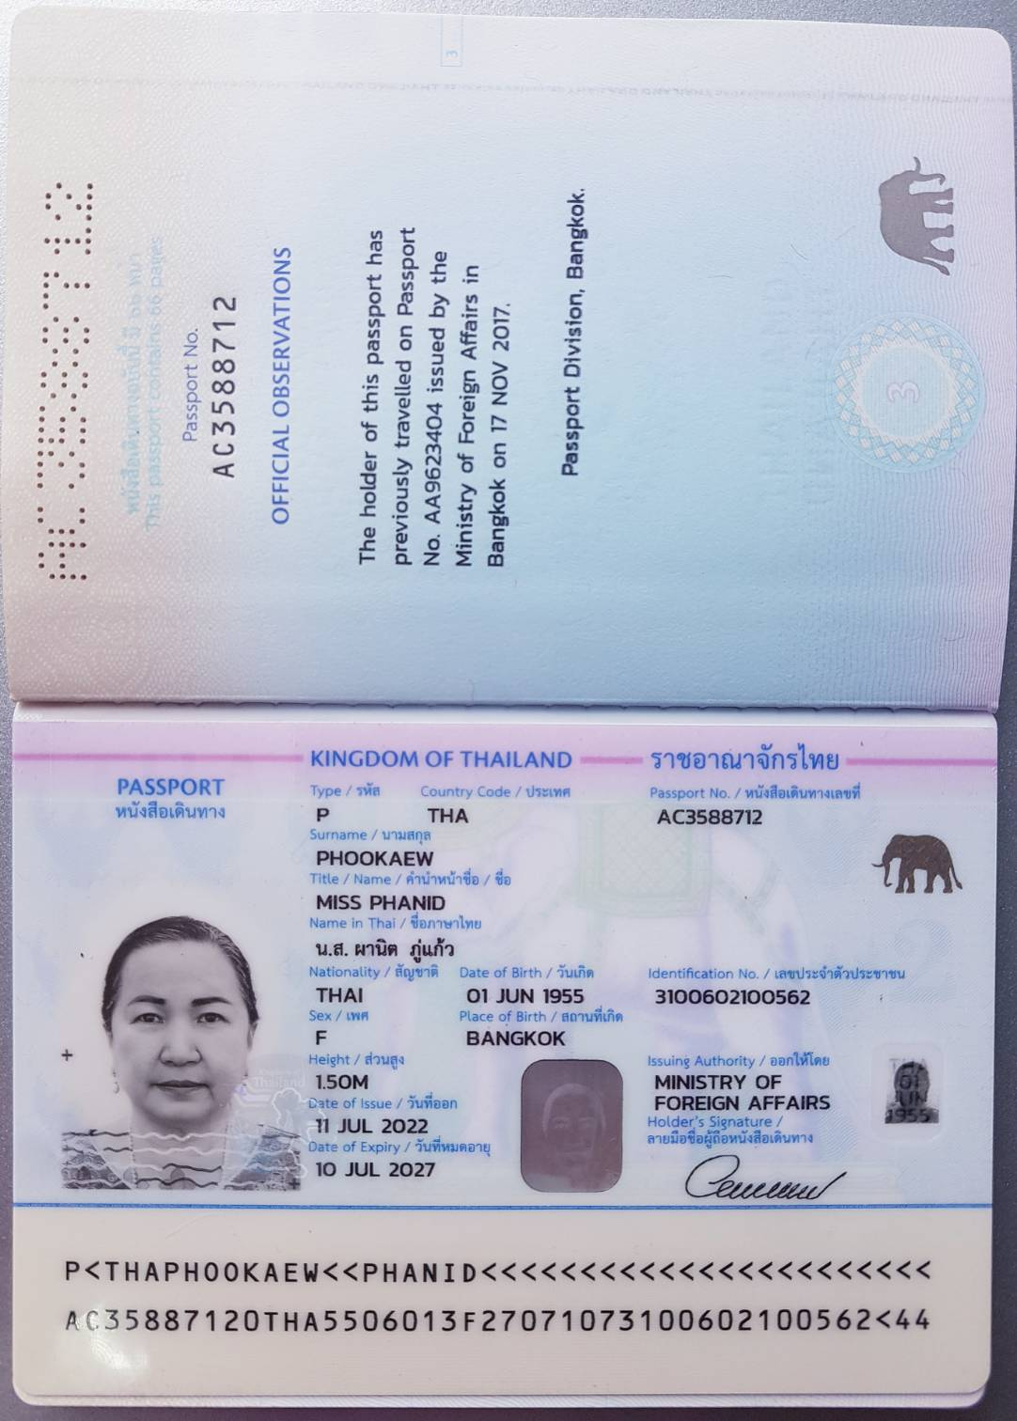

**APPENDIX – C. Buyer’s Company Certificate**

**APPENDIX – D. SELLER’S COMPANY CERTIFICATE & TRADING OBJECTIVE/LICENSE**

In accordance with the Description of Objectives No. 35 registered as a juristic person registration no. 0105564125842 under the Civil and Commercial Code:

Description of Objectives No. 35 (Trading Objective/License)

*"Execution of international trade, import, export of expired, recyclable and used international precious metals, land and air transport, import and export by third party logistics".*

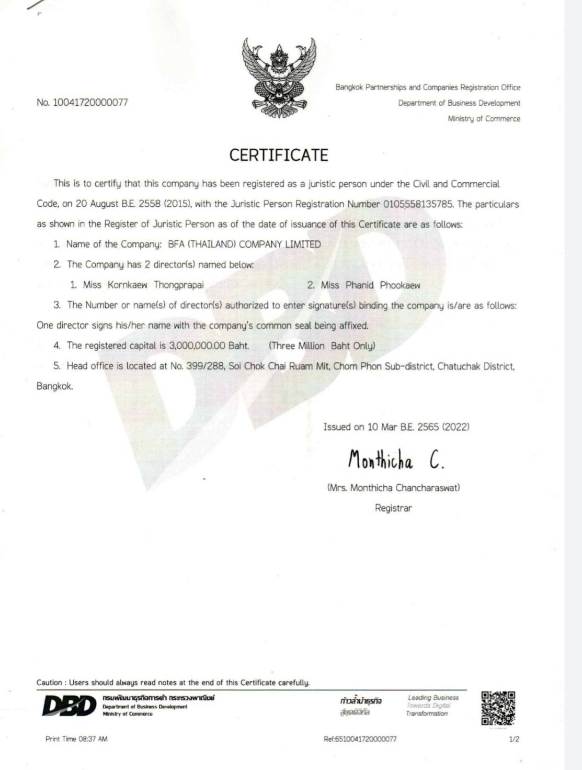

**APPENDIX-E MT700 DLC VERBIAGE**

**(OPTIONAL, THE BUYER CAN USE ANOTHER TYPE OF PAYMENT GUARANTEE VIA SWIFT)**

(DRAFT ONLY - SUBJECT TO THE ISSUING BANK STANDARD SWIFT FORMAT AND THE SWIFT PROTOCOL)

**DOCUMENTARY LETTER OF CREDIT *** MUST BE ISSUED VIA SWIFT MT 700 \*\*\***

* FORMAT UPC XXX

------------------

Instance Type and Transmission

------------------

Original received from SWIFT

Priority:

Message Output Reference:

Correspondent Input Reference:

------------------

Message Header

------------------

Swift Output:

Sender:

Receiver: XXX

------------------

Message Text

------------------

27: SEQUENCE OF TOTAL

1/1

40A: FORM OF

DOCUMENTARY LETTER OF CREDIT IRREVOCABLE, NON-TRANSFERABLE,

xx/xxxxx/xxxx

31D: DATE

AND PLACE OF EXPIRY

-

DAYS FROM DATE OF ISSUE

50: APPLICANT

xxxxxxxxxxxxxxxx

59: BENEFICIARY

Xxxxxxxxxxxxxxxx

328: CURRENCY CODE AMOUNT

CURRENCY: UNITED STATES OF AMERICA

AMOUNT: USDS._______.

/ (FULL CONTRACT VALUE HERE)

39A: PERCENTAGE CREDIT AMOUNT TOLERANCE

05/05

41A: AVAILABLE WITH/BY SWIFT ADDRESS

IF CONFIRMED THEN NEGOTIATION RESTRICT TO CONFIRMING BANK

43P: PARTIAL SHIPMENTS

NOT ALLOWED

43T: TRANSSHIPMENTS

NOT ALLOWED

44A: ON BOARDIDISP/TAKING CHARGE AT

ANY MAIN PORT IN XXXXXXXXXXXXXXX

448: FOR TRANSPORTATION TO

xxxxxxxxxxxxxx

44C: LATEST DATE OF SHIPMENT

20 -25 DAYS FROM DATE OF ISSUE

45A: DESCRIPTION OF GOODS AND / OR SERVICES

COMMODITY: INTERNATIONAL PRECIOUS METAL HS71081200 IN BAR FORM- IMPORTABLE AND EXPORTABLE WORLDWIDE ORIGINAL GOLD REGISTERED AU BARS IN 1 KG AND 12.5 KG WEIGHT (GOLD EXPIRED)

UNIT PRICE:

TOTAL QUANTITY:

DELIVERY:

SPECIFICATION:

PACKING:

46A: DOCUMENTS REQUIRED WILL BE MENTIONED IN THE LETTER OF CREDIT

47A: ADDITIONAL CONDITIONS

TOLERANCE 5 PCT MORE OR LESS ON VALUE AND QUANTITY ACCEPTABLE

"PCT"PERCENT AND "0/0" ARE OF THE SAME MEANING

ALL BANK CHARGES IN THE BUYER'S BANK ARE FOR THE BUYER'S ACCOUNT AND ALL BANK CHARGES IN THE SELLER'S BANK ARE FOR THE SELLER'S ACCOUNT.

**THIS LETTER OF CREDIT WILL BE AUTOMATICALLY OPERATIVE UPON APPLICANT RECEIVED A PERFORMANCE BOND OF 2 PCT OF THE SHIPMENT VALUE AND ACCEPTABLE AND CONFIRMED PROOF OF PRODUCT ON A REVOLVING BASIS.**

ALL DOCUMENTS MUST BE ISSUED IN ENGLISH LANGUAGE CHARTER PARTY BILL OF LADING AND

THIRD PARTY DOCUMENTS ARE ACCEPTABLE

THIS LETTER OF CREDIT WILL AUTOMATICALLY REVOLVE XXXXX TIMES UNTIL THE TOTAL QUANTITY OF XXXXXXXX (xxxxxxxxxxxxx) METRIC TONNES (±5%) HAS BEEN SHIPPED

71B: CHARGES

ALL BANKING CHARGES AND COMMISSIONS OTHER THAN THE ISSUING BANK'S CHARGES ARE ON THE BENEFICIARY'S ACCOUNT

48: PERIOD FOR PRESENTATION

WITHIN XX

DAYS OF SHIPMENT DATE

49: CONFIRMATION INSTRUCTION

CONFIRM

53A: REIMBURSING BANK

-

BIC

TO BE COMPLETED BY ISSUING BANK

78: INSTRUCTIONS TO PAYING/ACCEPTING/NEGOTIATING TO BE COMPLETED BY ISSUING BANK

72: SENDER TO RECEIVER INFORMATION

//KINDLY CONFIRM HAVING NOTIFIED AND CONFIRMED LIC TO BENEFICIARIES BY RETURN SWIFT QUOTING YOUR REFERENCE

*** MUST BE ISSUED VIA SWIFT MT 700 ***

**APPENDIX – F. seller’s performance bond guarantee via swift mt760 verbiage**

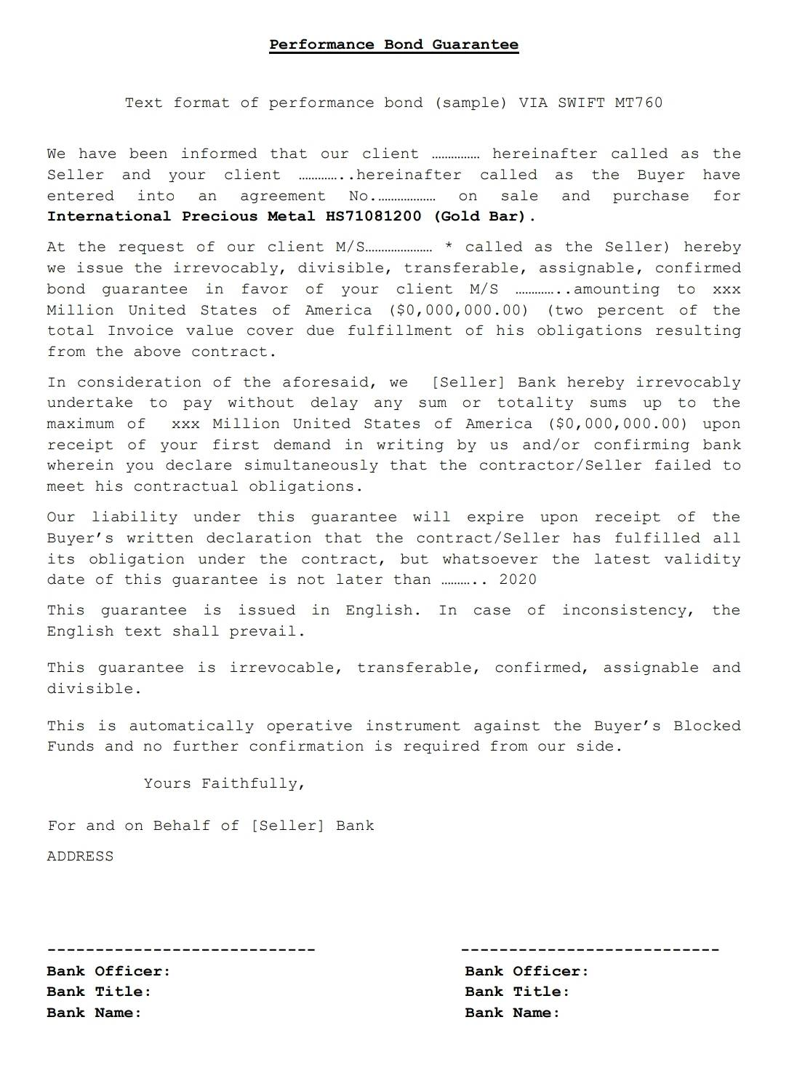

**APPENDIX – g**. **END SELLER’S CONFIRMATION OF PRODUCT VERBIAGE VIA SWIFT MT600/699 (P.1/2)**

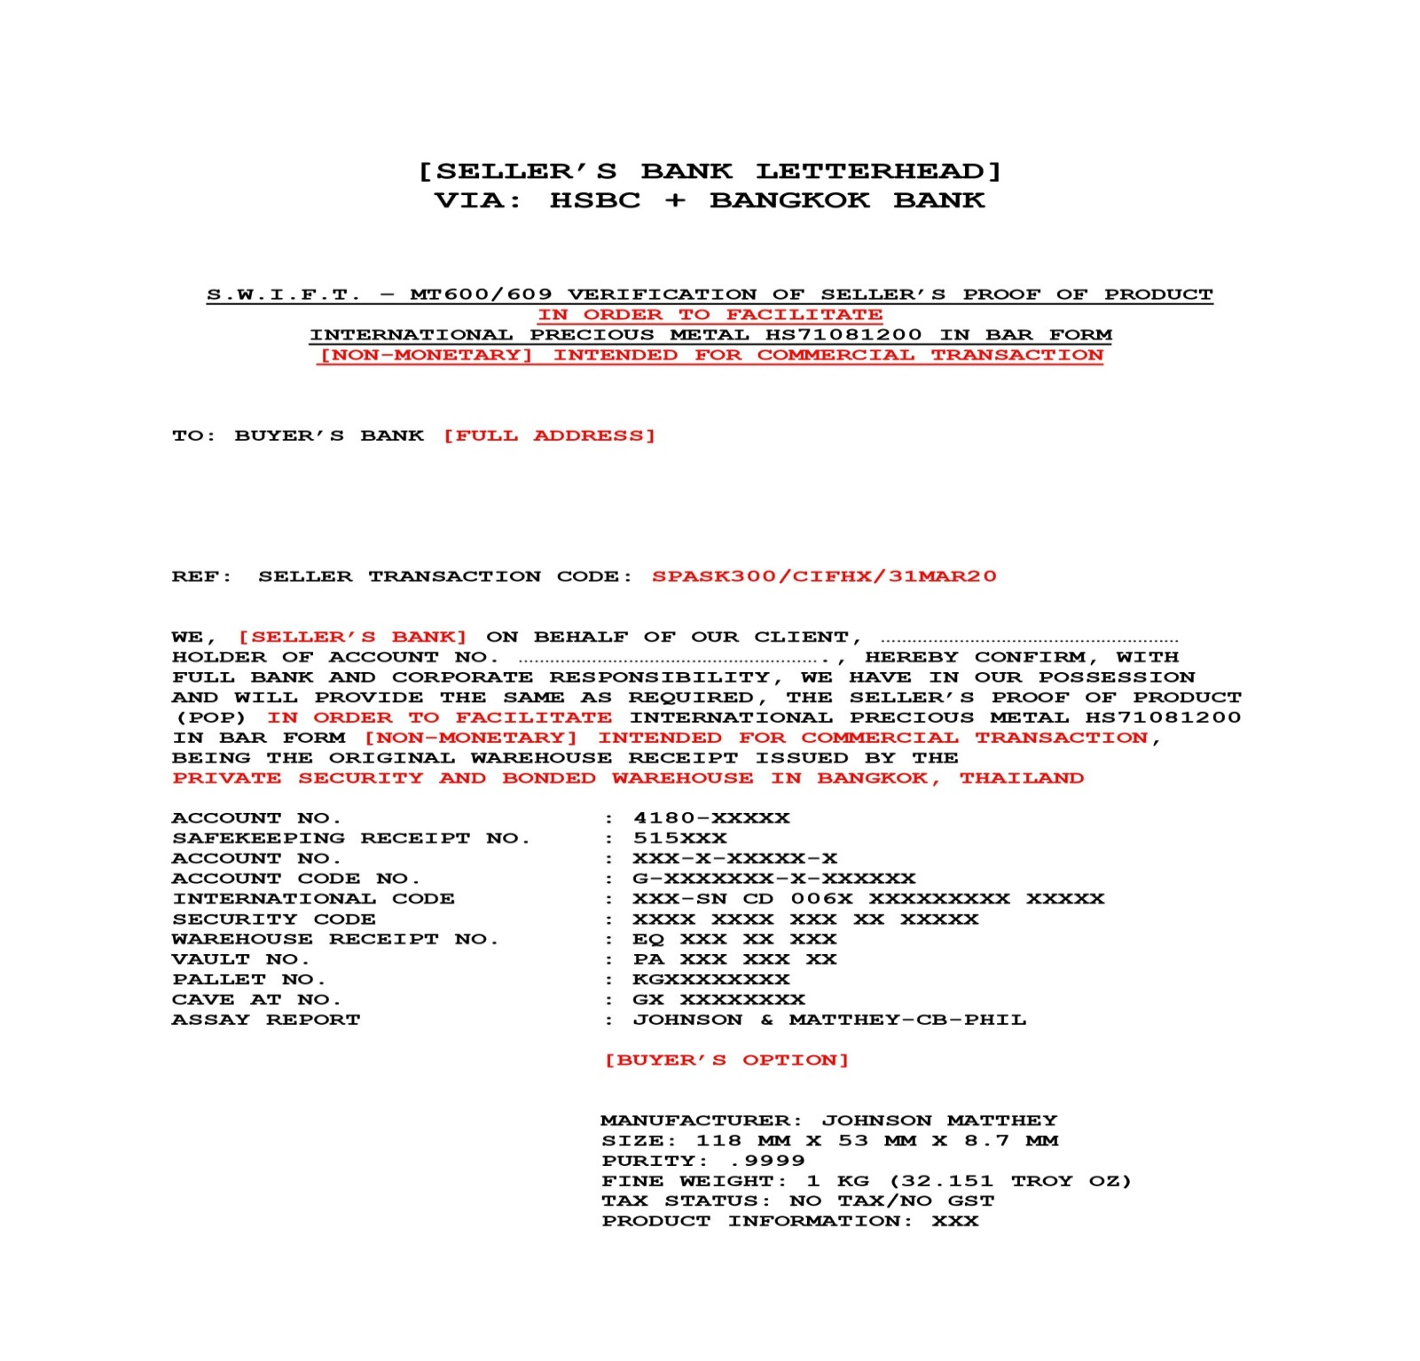

**APPENDIX – g**. **END SELLER’S CONFIRMATION OF PRODUCT VERBIAGE VIA SWIFT MT600/699 (P.2/2)**

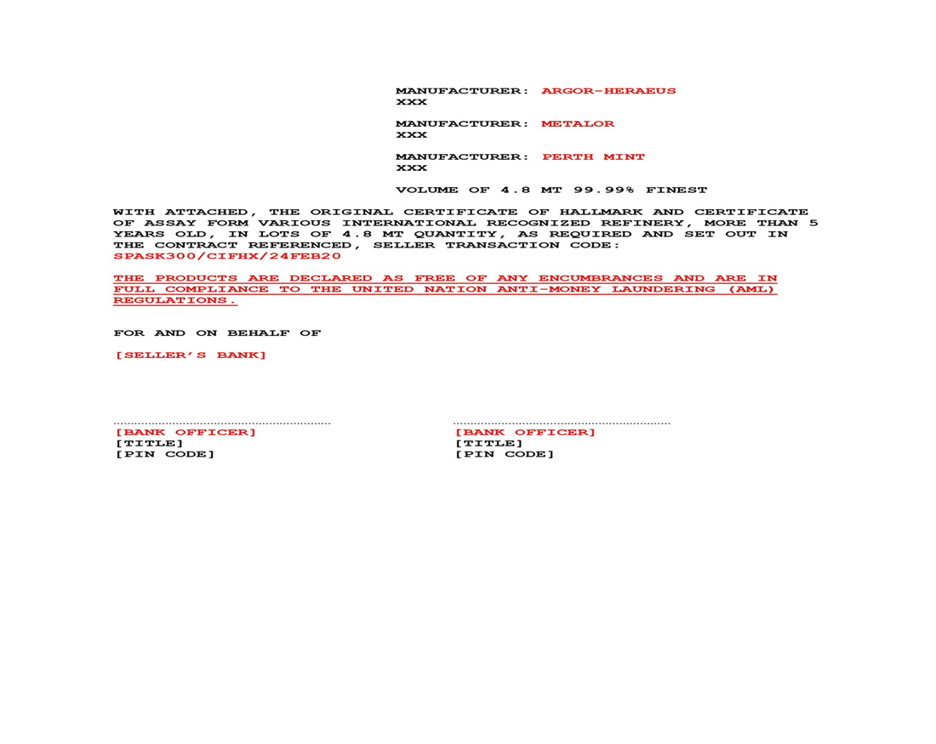

**Appendix - h. Verbiage DCL Depository confirmation letter**

Dear Sirs,

Regarding my deposit of Gold, Facility No .................. I intend to visit my deposit in your depository (Security Warehouse/ Bonded Warehouse) from Monday, XXth  of XXX 2021 onwards, together with our respected Buyer and his Assay team.

1) Please be so kind to confirm this today via email to me.

2) Please be so kind and send additionally a confirmation email for XXX kg/MT of gold with my below mentioned code and the following content to the Buyer: XXX

To re-confirm your confirmation email and our invitation to the Buyer, we would like to announce the following code: XXX (e.g.A5e43) to you and to the Buyer, so that the Buyer can call you in advance to verify the appointment.

This Email with your written confirmation of granting Access for Buyer’s Assay & Payment team to the Depository should describe and contain:

* Date & time of the invitation into the depository
* Available quantity
* My Code
* The respective name, title, function, and Phone number of the responsible person in your depository, for the contact of the Buyer
* Date & time of availability to start with the Assay procedure of the gold
* Office (daily access) hours in the vaults,
* Available Space for Proof in the vaults or nearby,
* Maximum number of Buyer’s Assay specialists getting access (depending on the premises of the depository),
* Providing Internet access in the Depository for online bank to bank wire transfer,
* Providing facilities for exchange of respective Title deeds in the Depository,
* Providing a lockable meeting room in the Depository for Seller’s mandate and Buyer’s mandate and Buyer’s Assay team and Paymaster team, and for depositing the Assay technical equipment,
* Providing a depot vault for the proved items in the Depository.

Thank you in advance.

Best regards

Seller

**APPENDIX I. SHIPMENT SCHEDULE**

**The Tranche Schedule (Negotiable)**

Total quantity 40 MT with 400 kilogram trial / one year contract

|  |  |  |  |
| --- | --- | --- | --- |
| Tranche | Timing | Quantity | Remark |
| **1** | week | 400 Kilogram |  |
| **2** | week | TBA |  |
| **3-12** | week | TBA | Total quantity 40 MT with 400 kilogram trial / one year contract |

|  |
| --- |
| **“ELECTRONIC SIGNATURE IS VALID AND ACCEPTED AS HAND SIGNATURE”** |
| **EDT (Electronic document transmissions)**  **EDT (Electronic document transmissions) shall be deemed valid and enforceable in respect of any provisions of this Contract. As applicable, this Agreement shall be:**  **1. Incorporate U.S. Public Law 106-229, ‘‘Electronic Signatures in Global and National Commerce Act’’ or such other applicable law conforming to the** |
| **UNCITRAL Model Law on Electronic Signatures (2001) and**  **2. Electronic Commerce Agreement (ECE/ TRADE/257, Geneva, May 2000)** |
| **adopted by the United Nations Centre for Trade Facilitation and Electronic Business (UN/CEFACT).**  **3. EDT documents shall be subject to European Community Directive No. 95/46/EEC, as applicable. Either Party may request a hard copy of any document that has been previously transmitted by electronic means provided, however, that any such request shall in no manner delay the parties from** |
| **performing their respective obligations and du~~t~~ies under EDT instruments.** |

**** End of Agreement ****

(Note: This document is strictly confidential and it is forbidden to disclose to any persons not party to the document)