**CURRICULUM VITAE**

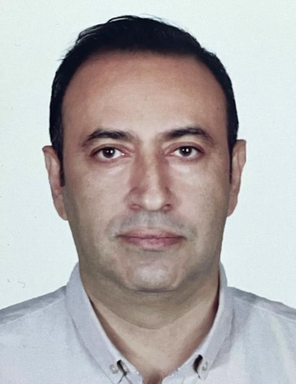

[salim_mehran@yahoo.com](mailto:salim_mehran@yahoo.com)

**NAME & SURNAME:** Mehran Salim

**DATE OF BIRTH:** 19th Sep,1976

**PRESENT ADDRES: Gerichtsgasse 8/2/1A 1210 Wien**

**TELPHONE NUMBER:**  004368110130503

**MARTIAL STATUS:** Married

**MILITARY SERVICE:** Done

**EDUCATION:** B.S. in Civil Enginrering - Civil

Larestan University Iran

Iranian Engineering Code in Construction & Inspection

17 - 31 - 04898

**LANGUAGE:** Good Command in English & Persian (Write & Read & Speak) and

Also hardly speak German

**WORK EXPERIENCE AND QUALIFICATION:**

**More than 20 year experience in Oil and Gas project and Petrochemical field with international company such as TOTAL FINA ELF ,DORRIZ,MOGTADER SANAT,JOINT VENTURE OF TOYO/IDRO/JGC/DAELIM,ARIA NAFT SHAHAB and Industrial Projects Management of Iran COMPANY as a Site Manager, QC Manager , QC Coordinator and Technical Inspector in Site and head office .**

**-excellent communication and listening skills, with strong observational, analytical, and problem solving skills.**

**-Strong attention to detail, observation, organizational , and leadership skills.**

**-In-depth knowledge of quality control civil procedures and legal standards.**

**-Communicating with the employer and contractors and solving problems for the progress of the project .**

1. **Positon:** Site Manager

**Company:** Industrial Projects Management of Iran Co.

**Project:** South Pars Field Development Phases 17&18

**Location:** Assaluye, IRAN

**Period:** May-2018 upto March 2023

Construction and execution of the refinery based on executive and engineering plans using experts and skilled workers and experienced engineers along with advanced machines and equipment.

1. **Positon:** QA/QC Manager

**Company:** Industrial Projects Management of Iran Co. (IPMI)

**Project:** South Pars Field Development Phases 17&18

**Location:** Assaluye, IRAN

**Period:** Mar-2014 ~ May-2018

Co-ordinating with all inspectors according to ITP.

-Check the inspection report and take the corrective action to remove all raised NCR during working process.

- Review ,Revised and Confirmed QC Procedure

-Held on and arranging the KOM for each PO

-Supervision and control on quality of the all raw materials and equipments which has been purchased by procurement department.

- Follow-up of purchased materials from vendors to ensure quality

-Holding meetings with inspectors to solve problems

1. **Positon:** QA/QC Leader in Civil & Building Department

**Company:** ARIYA NAFT SHAHAB CO.

**Project:** South Pars Field Development Phases 15&16

**Location:** Assaluye, IRAN

**Period:** Feb-2008 ~ 31 Mar-2014

Inspection and cooperation in the implementation of the construction of all buildings, roads, equipment concrete foundations and also tank foundations like LPG TANKS required in the refinery.

1. **Positon:** QA/QC Sub Leader in Civil & Building Department

**Company:** TIJD Co. (Joint Venture)

**Project:** South Pars Field Development Phases 6,7&8

**Location:** Assaluye, IRAN

**Period:** 10,Sep-2004 ~ Feb-2008

Inspection and cooperation in the implementation of the construction of all buildings, roads equipment concrete foundations , concrete tanks for example LPG TANKS and also metal tanks required in the refinery.

1. **Positon:** Site Manager

**Company:** MOGTADER SANAT ARAK CO.

**Project:** South Pars Field Development Phases 1&2&3

**Location:** Assaluye, IRAN

**Period:** 20,Mar-2004 ~ Sep-2004

Construction and execution of the refinery based on executive and engineering plans using experts and skilled workers and experienced engineers along with advanced machines and equipment.

1. **Positon:** QC Inspector & Maintenance Maneger

**Company:** DORRIZ Engineering & Construction Co.

**Project:** Total South Pars Field Development phases 2&3

**Location:** Assaluye, IRAN

**Period:** Dec-2000 ~ Mar-2004

**Inspection of the construction and installation of metal structures and metal tanks like CONDENSATE TANKS and inspection of the construction of concrete buildings and concrete tanks, for example LPG TANKS**

**Head of the repair and maintenance group of the refinery**

1. **Positon:** Civil Engineer

**Company:** SADRA Co.

**Project:** 5 Apartment

**Location:** Shiraz, IRAN

**Period:** Jul-2000 ~ Dec-2000

**Supervising the construction of a five-story apartment**

**OTHER INFORMATION:** Safety Reward from TOTAL FINA ELF CO.