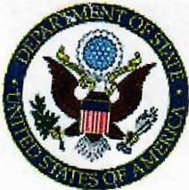

# THE UNITED STATES OF AMERICA

SOVEREIGNTY RIGHT FROM:NATHAN ROSENBERG,

ST:GEORGE’S GRENADA W.I.

LOCATION : green street /

GENERAL affairs;

Civil DIVISION FOIA & privacy office

Department of justice room 8314

1100 L street, NW

TO: SIR:SYLVESTER DERICK .F & ASSOCIATES,

ADRESS:CHAMBERS, 495 lucas street st:geo

/THE governor office of GRENADA

HIS/HER EXCELLENCY (COUNTESY)

03/04/23

(USA DOMINION)

TO: THE ADMINISTRATION STAFF:

AS part of this international foreign policy and treaties affairs .This matters are real i contact you on those affairs i ask many times to have them keep off of me. On the the property first think in the morning. They are on my case over and over as the investigation with the lawyer and china and others which i will explain in full in them . due to consular immunity guidance in such cases where all dead! Under SVG pm and those that form government this have to do with us authorities with hamas boys this launch invasion. Over the years in abuse and advantage blood and pain torture by the hands of those enemies.

ENC: MEMO

YOURS SINCERELY,

NATHAN ROSENBERG,

__________________

This are and well be a federal court matters in full light. Also is one why or other as they tell me that they get orders to do this to me.

YOURS SINCERELY,

N.R. ___________________________