Lesson 1.7 – Counting Principles
Learning Goal: To be able to use solve problems using different counting techniques.
Success Criteria: I will know I have achieved the Learning Goal when I can... • explain the difference between AND and OR counting • define permutations and combinations • solve problems by applying different counting techniques

AND counting: If one action can be done m ways and another action can be done n ways, then the number of ways one action AND the other action can be done is m x n. OR counting: If one action can be done m ways and another action can be done n ways, then the number of ways one action OR the other action can be done is m + n. Permutations: The number of ways to arrange r objects out of n distinct objects, where order is important. Combinations: The number of ways to arrange r objects out of n distinct objects, where order is not important.

Example: An outfit must be selected that consists of a shirt and a pair of trousers. There are three choices for the shirt: a red, a blue and a green one. There are two choices for the trousers: jeans or corduroys.
- List all the possible outfits.

- Explain how the number of outfits can be found from the numbers of choices for the shirts and trousers.

- Determine how the number of choices would change if you were told that an outfit consists of a shirt or a pair of trousers.

Example: There are twelve flights that can be taken from Frankfurt to Amsterdam on a given day, and there are three buses that can be taken from the Amsterdam airport to a hotel. Find the total number of ways in which the hotel in Amsterdam can be reached from Frankfurt using one of the flights and one of the buses.

Example: There are x flights and x +7 buses that can be taken from Mexico City to Guadalajara. Find x given that there is a total of 19 possible ways to get to Guadalajara from Mexico City by plane or by bus.

Permutations
There are _______ ways to arrange ______________ in a ____________________ when order
The number of ways to arrange out of , where order

where P stands for “permutations”

Example: Find the number of different ways that four parked cars can be arranged in a straight line.

Example: A three-digit combination lock has three wheels, and on each wheel are all the integers from 0 to 9. Find the total number of possible codes for the lock.
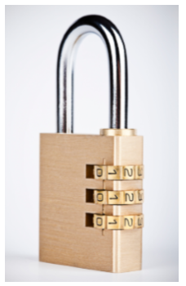

Example: Find the total number of different five-letter passwords that can be made from the 26 letters of the English alphabet if no letter can be used more than once.

Example: Lynx studies six subjects and has six textbooks, one for each class.
- How many ways are there to arrange three of the six textbooks on a shelf?

- Find how many ways there are to arrange all six books on a shelf such that the book for math and the book for physics are next to each other.

Combinations
Combinations are that can be made of out of if order .

Example: From a class of 25 students, a committee of 5 students to represent the class is to be chosen. If must include the class president. Find the number of ways that the committee can be selected.

Example: There are 8 girls and 5 boys on a volleyball team. Find the number of ways that the coach can choose a team of six players if it needs to have:
- three boys and three girls

- at least two boys and two girls

Practice Problems Kognity Assignment Page 57 #5, 7, 8, 10

