|  |  |
| --- | --- |
|  | **••••• • • e**  **COS M OS HIGH SCHOOL** |
| 4GecuooAce | [cosmoshighsc@gmail.com](mailto:cosmoshighsc@gmail.com) 0811294903 |

P/BAG 19002 KHOM DA NAMIBIA TEL. ( 212405 • FAX. (06 212533

2 February 2018

TESTIMONIAL

|  |  |
| --- | --- |
| TO WHOM | AY CONCERN |

This is to certify that Teopoline Simon, born 10/0711997 was a bona ide student of Cosmos High School from 2014 to 2017.

She wrote the NSSCO in the following subjects:

|  |  |  |
| --- | --- | --- |
| • | English | (Core Level) |
| • | Afrikaans | (Core Level) |
| • | Mathematics | (Core Level) |
| • | Biology | (Ordinary Level) |
| • | Physical Science | (Ordinary Level) |

* Developmental Studies (Ordinary Level)

Teopoline was a rather quiet learner, who was diligent in her studies. Teopoline has proven herself to be a socially well-adjusted young woman, who demonstrated her strength in a quiet manner. She was well liked by her teachers, as well as her fellow classmates because of her exceptional manners and friendly personality. During her time with us she was a Blood Ambassador for the Blood Donation Organisation.

She bears an excellent moral character. I wish lier a successful ca ree

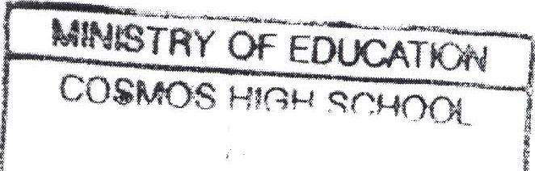

MOS HV-4

0 2 ..ri 2'01,i3 I

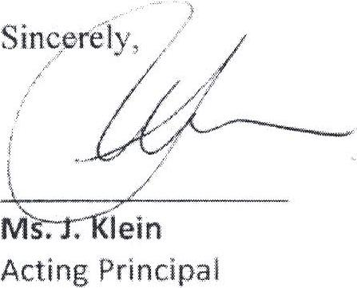

1

PFUVATE ElPfd *end..* ,..;-tt..,44A:.illitt I

TEL: 061-212405 ,

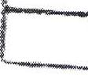

WINDHOEK REGf oh,