**REGISTERED FINANCIAL PLANNERS INSTITUTE PHILIPPINES** 505 East Tower, Philippine Stock Exchange Center, Ortigas, Pasig City Tel. No. (632) 6879856 or (632) 2633221 • Fax No. (632) 7062212 Website: [www.rfp.ph](http://www.rfp.ph) • [info@rfp.ph](mailto:info@rfp.ph)



**PHILIPPINES**

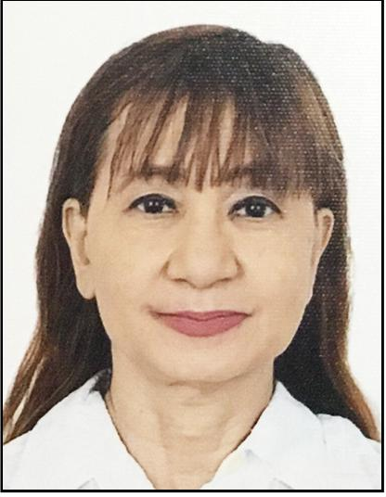

**ASSOCIATE FINANCIAL PLANNER FORM**

Suffix:

|  |  |  |  |
| --- | --- | --- | --- |
|  | **PERSONAL DATA** |  |  |
|  | Mr./Ms./Mrs./M iss/Dr. |  | Last/Family Name/Surname: |
| * Student |  |  |  |
|  | First/Given Name: |  | Middle Name: |
| * Professional |  |  |  |
|  | Date of Birth (mm/dd/yyyy): | / | / / |
|  |  |  |

EDUCATION & PROFESSIONAL INFORMATION

* BACHELOR'S DEGREE

Year:

Course:

University:

* **MASTERAL Ei DOCTORAL** Year:
    
  Course:

CONTACT INFORMATION (Please indicate your contact preference)

**HOME MAILING ADDRESS**Home / Bldg. No., Street:

City:

University:

* **OTHER** Year:

Course:

University:

Licence No.: Year:

AFP TRAINING PROVIDER:

|  |  |  |  |  |  |
| --- | --- | --- | --- | --- | --- |
| Province: |  |  | Postal Code: |  |  |
| Phone Number:  Mobile Number:  Personal E-mail Address: | |  |  |  |  |
|  |  |  |  |
|  |  |  |  |

PAYMENT INFORMATION

AFP Membership Fee Php 2,500

Courier fee Php 300

**TOTAL Php 2,800** Preferred mailing address: 3 Home o Business

PAYMENT OPTIONS

1. Direct deposit at any BDO branches:

Bank name: BDO

Account name: Association of RFPs in the Philippines, Inc.

Account No.: 343-017-7825

1. Payment at RFP office.

BUSINESS MAILING ADDRESS

Position:

Company Name:

Unit/Bldg. No., Street:

City:

Province: Phone Number:

Postal Code:

Fax Number: (Country code/Area code/City code)
  
E-mail Address:

ACCEPTANCE OF SUBSCRIPTION

I declare that at of the information contained in this application is true and correct and I agree to provide any supporting documentation requested by the Institute. If accepted, I agree to abide by the Registered Financial Planners Institute Philippines' Code of Professional Conduct and Continuing Professional Education requirements. I understand that I must renew my subscription annually to enjoy the services provided by the Institute including eligibility privileges and retention of professional designation.

Signature Date:

|  |  |  |  |  |  |  |  |  |  |  |  |  |
| --- | --- | --- | --- | --- | --- | --- | --- | --- | --- | --- | --- | --- |
| **OFFICIAL USE ONLY:**  INVOICE NO.  OR NO. | | |  |  | INVOICE DATE:  DATE PAID:  VERIFIED: | |  |  |  | APPLICATION RECEIVED ON:  [ ] COMPLETED REQUIRED DOCUMENTS  [ ] APPROVED MEMBERSHIP NO.  [ ] NOT APPROVED REASON: | | |
|  |  |  |  |  |
| DCR NO. | |  |  |  |  |  |  |
|  |  |  |  |  |  |  |  |  |  |
|  |  |  |  |  |  |  |  |  |  |  |  |  |