**FAWAZ AL-SHAM MARI**

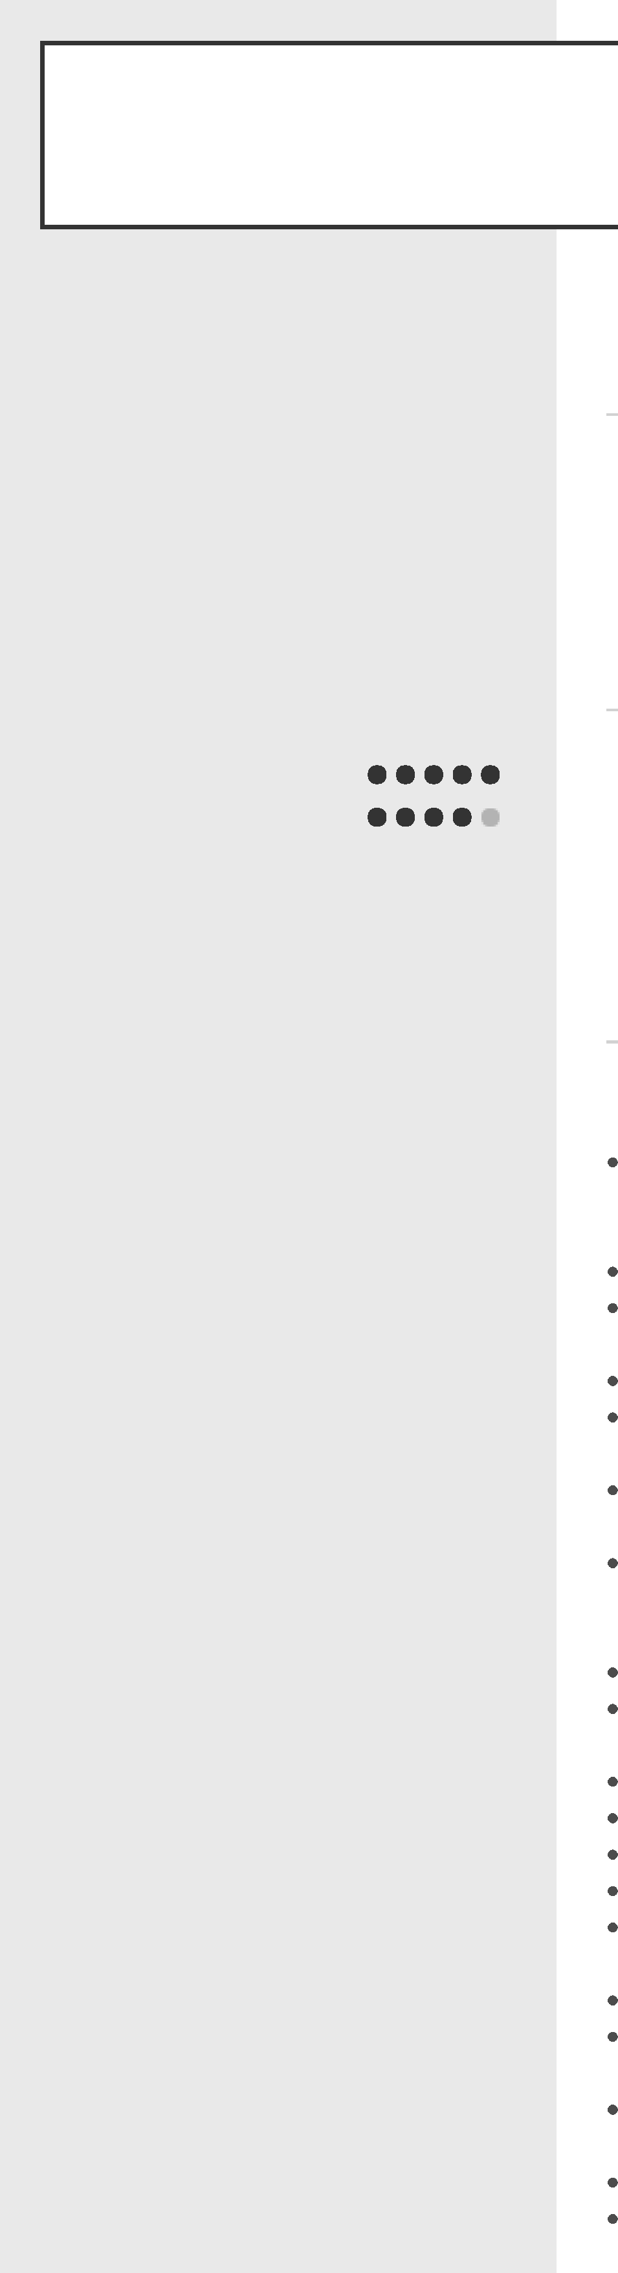

**PERSONAL**

I am seeking a position with a company where I can perform to the best of my abilities and knowledge, to grow with the company and become an asset to the organization.

**Name**

Fawaz Al-Shammari

**Address**

Saudi Arabia Khafji

**Phone number**

0594400015

**WORK EXPERIENCE**

**Plant Field Operator** Oct 2018 - Present

Saudi Aramco, Tanajib GOSP

3 years operator experience within above average performance level Work as field operator in Tanajib GOSP plant, North Area Producing Department, Saudi Aramco which is producing (. ) BPD of crude oil

**Email**

[fawazsuwailem@gmail.com](mailto:fawazsuwailem@gmail.com)

**LANGUAGES**

**EDUCATION AND QUALIFICATIONS**

**Arabic English**

**Diploma**

Oct 2018 - Jan 2020

Saudi Aramco Industrial Training Center, Ras Tanura

I joined Saudi Aramco (ITC) for oil and gas diploma program in Ras Tanura Training Center and graduated on 2020 as certified field operator from oil and gas plant in Saudi Aramco Training Apprentices Program

**SKILLS**

Monitoring and operating process control equipment, including dealing with all types of valves, shipping pumps, gas compressor and air compressor

Operating plant equipment and system and interpreting plant procedures.

Adjusting controls to operate equipment and controls at periodic intervals, thereby detecting malfunctions more efficiently.

Responding efficiently to emergencies.

Visually inspecting equipment and controls at periodic intervals to detect malfunctions or need for repair, readjustment, or lubrication.

Implementing safe work practices and participating in proactive safety culture while ensuring safety for the employee, public, and environment at all time. Operating area equipment in a safe and efficient manner in order to produce the maximum rates possible while ensuring the highest quality product is produced to meet specifications

Maintaining area equipment to ensure operational reliability at all times. Decision making for the operation of the process and keeping process within designated limits.

Making necessary adjustments to maintain normal operation of equipment. Performing routine checks of equipment.

Lock out, hot work, and other safety procedure compliance.

Housekeeping in the plant area to ensure a safe and clean workplace. Working under pressure and emergency situations to keep the plant in safe condition

Performing quality assurance tasks to promote accuracy and minimize mistakes. Analyzing and measuring final products with precision tools to confirm compliance to specifications and standards.

Maintaining knowledge of industry policies and procedures to set up and operate equipment safely.

Conducting inspection of in‑process or finished product.

Recognising upset conditions, determining cause, and took appropriate corrective action.

|  |  |
| --- | --- |
|  | Providing on-the-job training to newly hired workers and team members. Dealing with all safety tools  Ability to use all operation documents such as P&IDs, PFDs, OIM and procedures Incident, near miss and unsafe condition reporting |

|  |  |
| --- | --- |
| **EXTRA SKILLS**  **- team worker**  **- Active communication**  **- Active lessening**  **- Presentation and Email communication**  **- Reporting and reviewing reports** |  |

**COURSES**

* Self-Contained breathing apparatus
* Industrial fire safety safety awareness
* Heart-saver CPR course
* Gas testing program
* Confined space entry
* Hazard recognition and control
* H2S safety course
* Lock-out Tag-out course ( LOTO )
* ARC Flash awareness program
* GOSP Outside operator course
* English level 6 functional
* Cybersecurity essentials
* Math 5 technical
* English 5 craft, technical and operator