|  |  |
| --- | --- |
| AF 12>  **e,**  **foc**  *Funded by Dutch* Gouernmen t | C**)**#Consortium **for** Climate Change **Ethiopia (CC-E** |

25/01/2023

Dear Esteemed Partner,

RE: **INVITATION TO THE AFRICAN ACTIVISTS FOR CLIMATE JUSTICE (AACJ) GLOBAL COORDINATION MEETING**

I am hereby pleased to formally extend an invitation to attend the African Activist for Climate Justice, AACJ, Global Coordination Meeting set to take place in Addis Ababa, Ethiopia from the 5th-lOth February 2023.

The retreat is premised on the critical need to strengthen effective coordination systems and clarify the ways of working within the consortium. It shall convene the Project Governance Group (PGG), Project Management Unit (PMU), AACJ Country leads, membership of the technical workstreams, the Country Coordinators from the country consortium lead partners in the 8 countries of focus, members of the decentralized PMU and representatives from the Dutch Ministry of Foreign Affairs. The overall goal for the global coordination meeting is to provide a space for dialogue, sharing, peer learning, problem-solving and creating new knowledge and understanding within the AACJ consortium.

As a key stakeholder in the AACJ project and in the climate justice movement, your input is considered essential to the discussions that will be held during the retreat. We have herein attached the concept note for your reference and preparation. Kindly be informed that PACJA shall cater for your DSA, travel and accommodation. Further, an information note shall be circulated in due course. Trusting that you will accept this invitation and looking forward to your invaluable participation.

Sincerely,

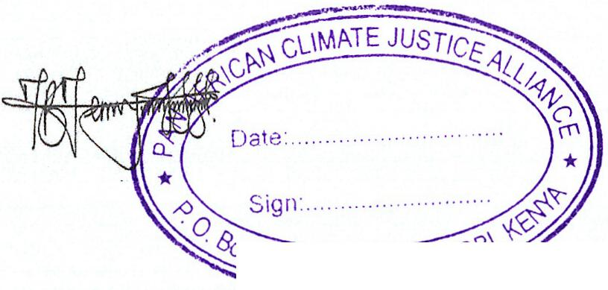Head of the Project Management Unit -AACJ National Coordinator-CCC-E



'1-5/005- 00200 NP'‘\‘'

Benson Simba Yonas Gebru

